**xfSteps No. 1 to 5 are similar for ios and Android setup on mac**

**For Mac, few points need to keep in mind.**

1. Unlike Windows machine, here Command key is used instead of Control

Command +S: Save

Command +C: Copy

Command +V: Paste

Command +Tab: Moving from one window to another

1. In windows we use cmd to run the commands, in macbook we have terminal (can be search using Finder)

**Step 1. Open Terminal and run below Command to install Homebrew (Homebrew is package manager for MacOS and through it you can install, uninstall, update software in mac)**

**Run this:**

/bin/bash -c "$(curl -fsSL <https://raw.githubusercontent.com/Homebrew/install/HEAD/install.sh>)"

Note: (Above is complete command to install homebrew)

🡪 If it is asking for password, then enter your System Password (Password to login into system)

🡪 Press Enter/Return to continue for installation

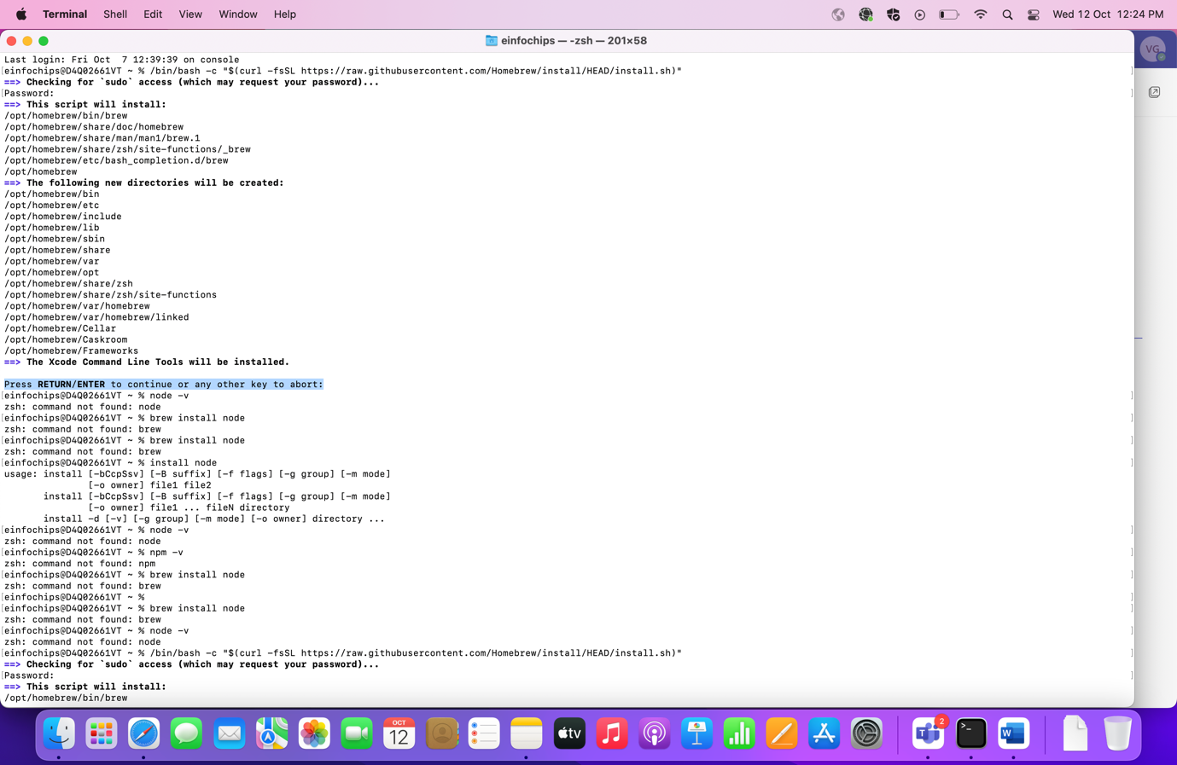

🡪 It will start downloading and at last the message will be displayed that Installation is completed successfully with instruction to run below three commands

Run these three commands in your terminal to add Homebrew to your **PATH**:

**Run these:**

1. echo '# Set PATH, MANPATH, etc., for Homebrew.' >> /Users/einfochips/.zprofile

2. echo 'eval "$(/opt/homebrew/bin/brew shellenv)"' >> /Users/einfochips/.zprofile

3. eval "$(/opt/homebrew/bin/brew shellenv)"

**Step 2. Run below command in terminal to install node (Node js/npm is required for Appium Server)**

**🡪Run this:**

brew install node

🡪Once installation is completed run the below commands to check the node version

**🡪Run these:**

node -v

npm -v

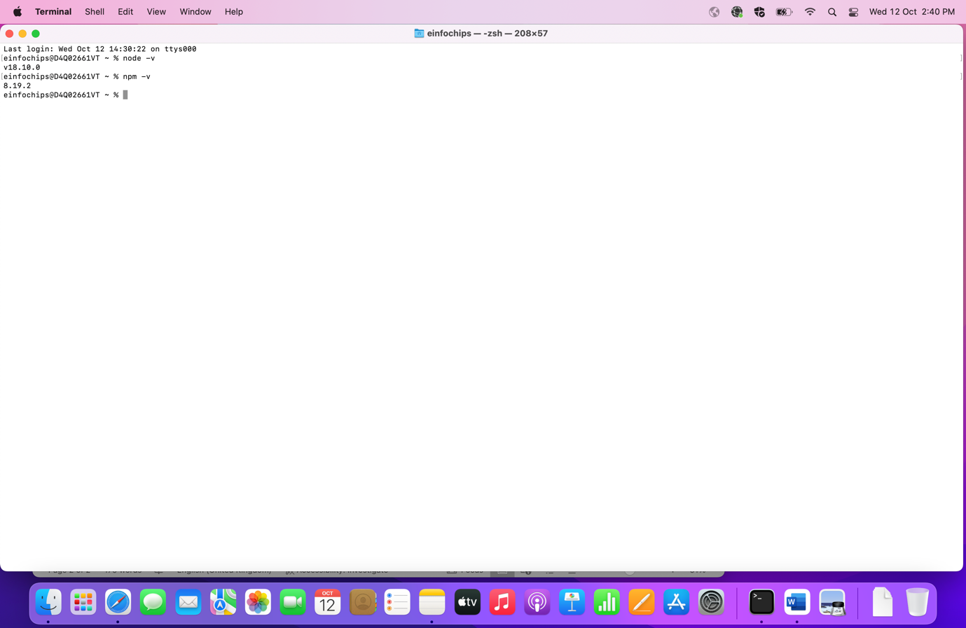

**Step: 3. Install Appium server using npm command (We can start the server by GUI or through command and here we will work on both in step 3 and 4)**

**🡪Run this:**

npm install -g appium

🡪Once installation is completed, run the below command to check the version and to verify that server is started or not.

**🡪Run this:** (to check version of Appium)

appium -v

**🡪Run this:** (to start appium server)

appium

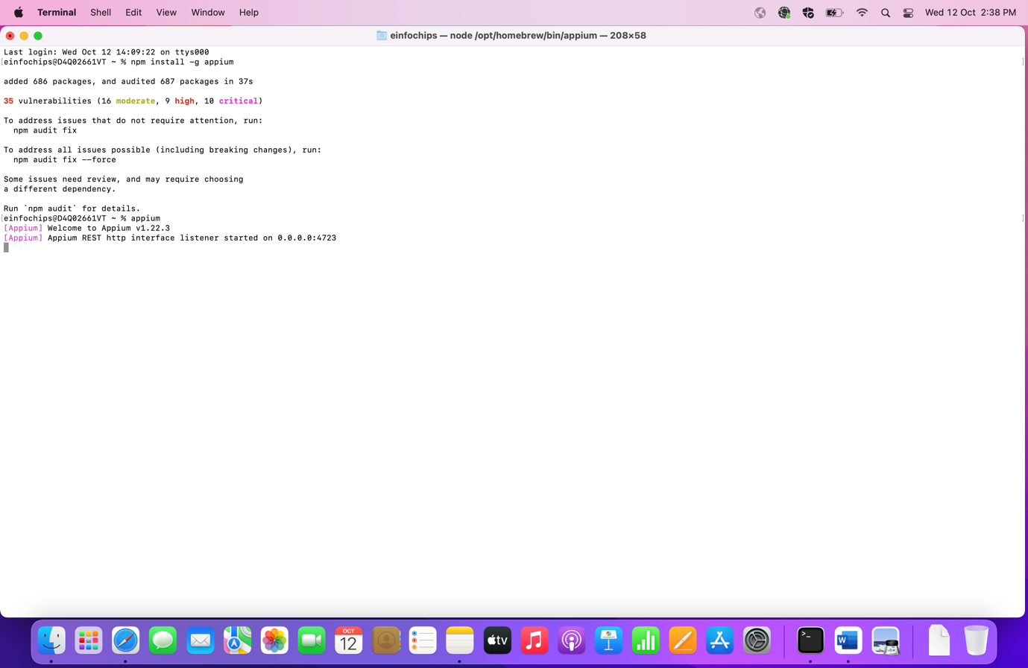

**Step 4. Download and install appium server using Appium Desktop Client**

🡪Go to below URL and you will find the different version of Appium Desktop Client for different OS.

<https://github.com/appium/appium-desktop/releases/tag/v1.22.3-4>

🡪Download the version for macOS as shown in below screenshot

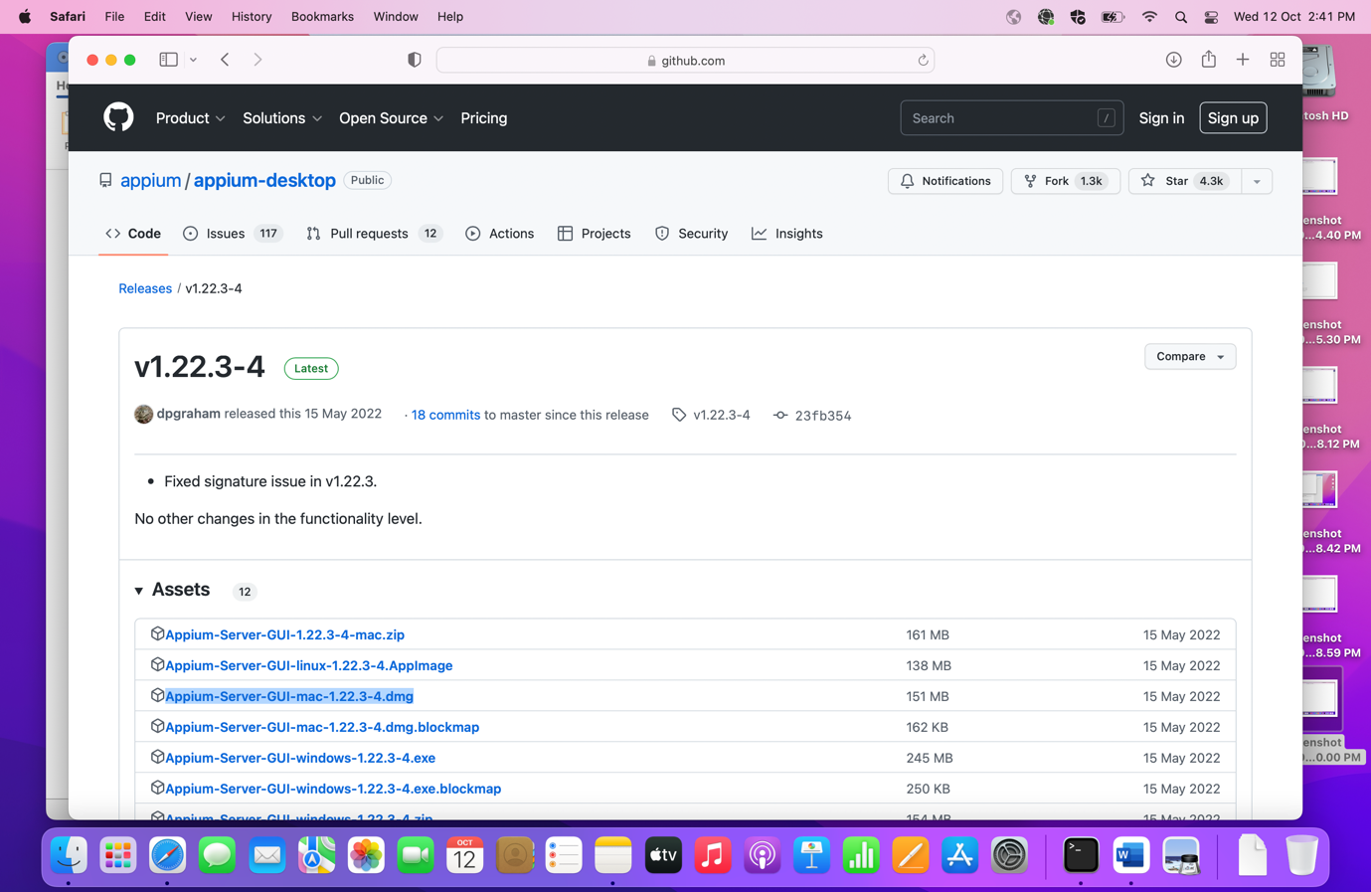

🡪Once it is downloaded, a pop up will be displayed where You can move your Appium Server GUI to Application.

🡪Drag it to the Application and then verify Appium Server GUI is available in Application folder now.

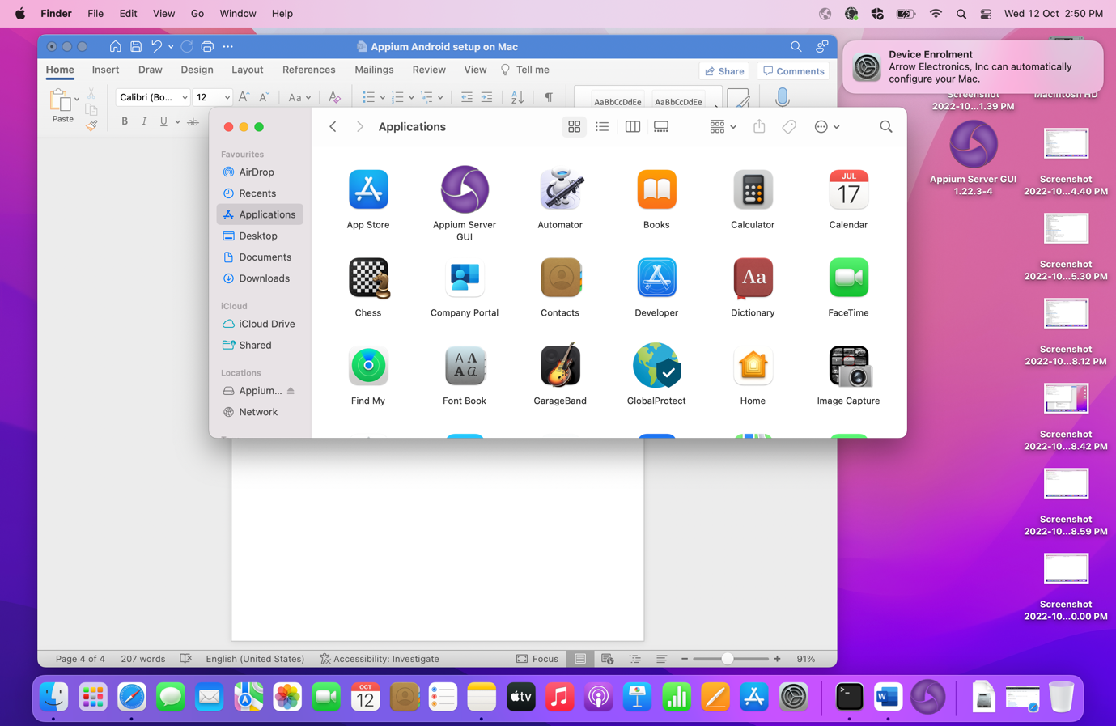

🡪Now open the Appium Server and click on Start Server and verify that server is launching properly or not.

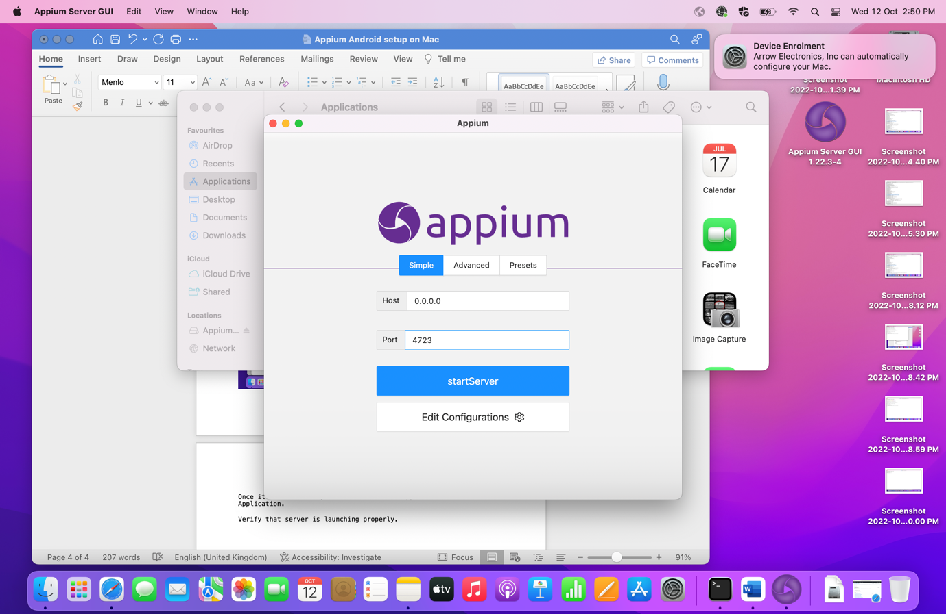

**Step 5. Download and install Appium Inspector (Appium Inspector is used to locate the mobile elements. We can find the elements by id, xpath, class etc..)**

🡪Go to below URL and you will find different Appium Inspector

<https://github.com/appium/appium-desktop/releases/tag/v1.22.3-4>

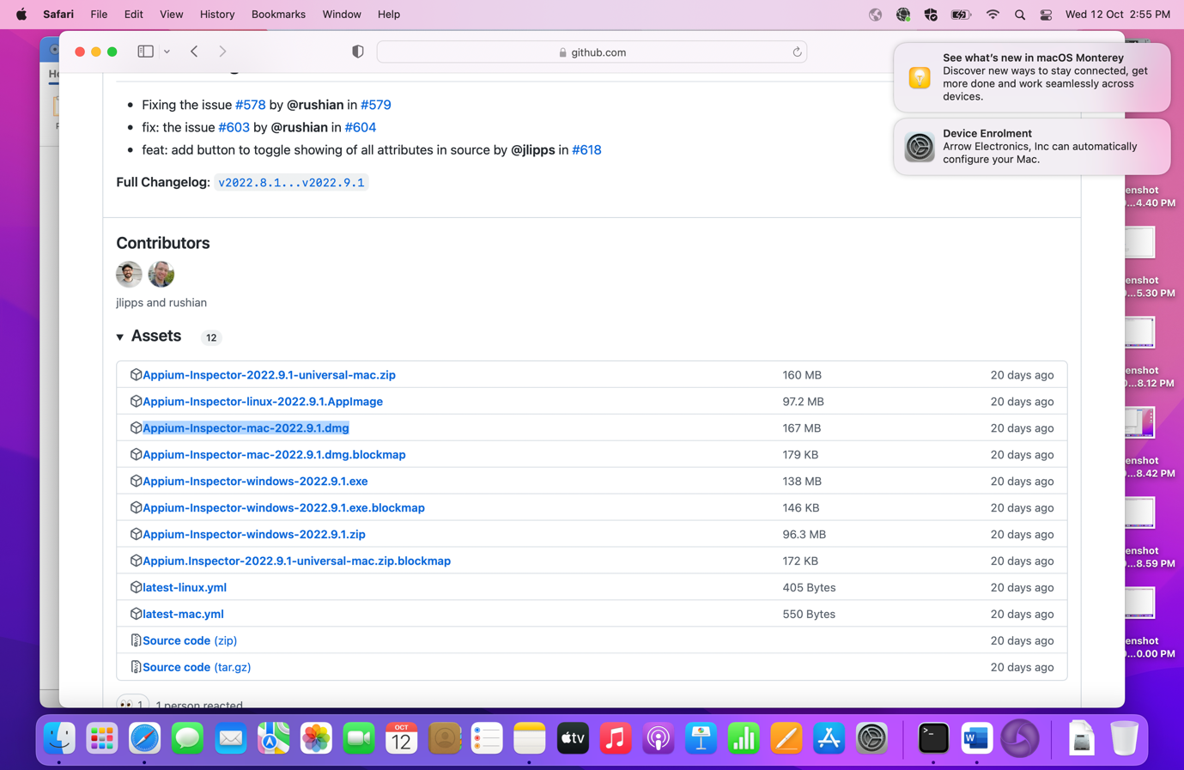

🡪Once it is downloaded, a pop up will be displayed where you can move your Appium Inspector to Application.

🡪Drag it to the Application and then verify Appium Inspector is available in Application folder now

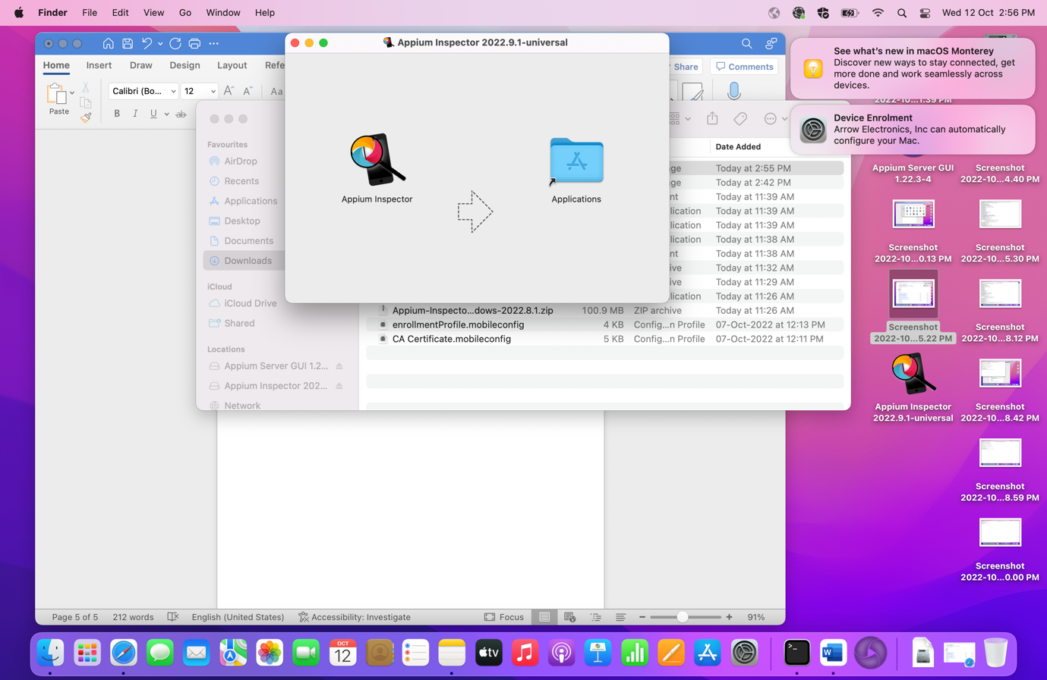

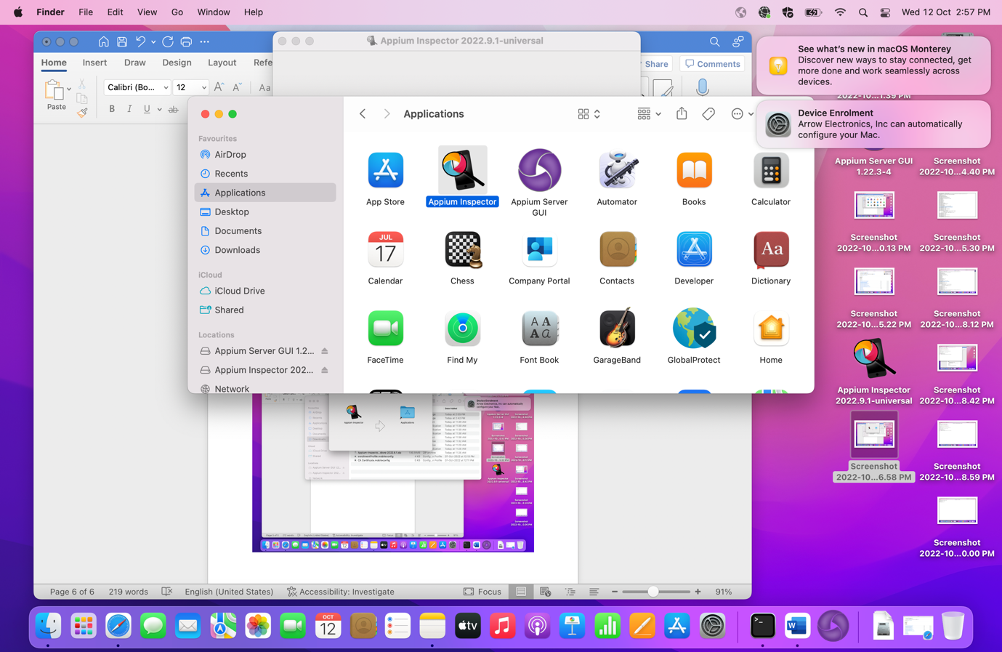

🡪Launch Appium Inspector

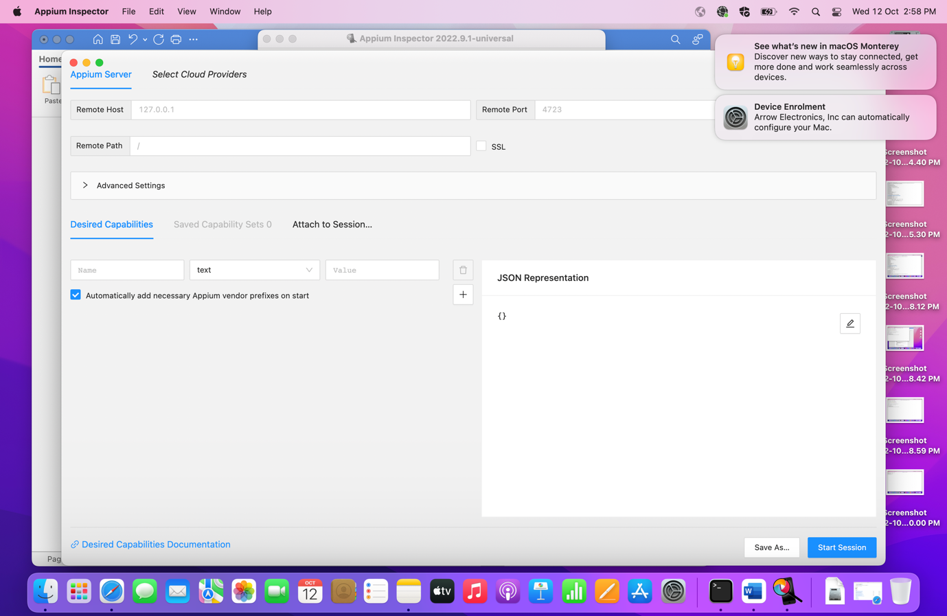

**Step 6. Install Java JDK (For specific project like POM, it might be the case where Java 18 will not support in that case you need to go with lower version of Java)**

🡪Download JDK from given below link

<https://www.oracle.com/java/technologies/javase/jdk18-archive-downloads.html>

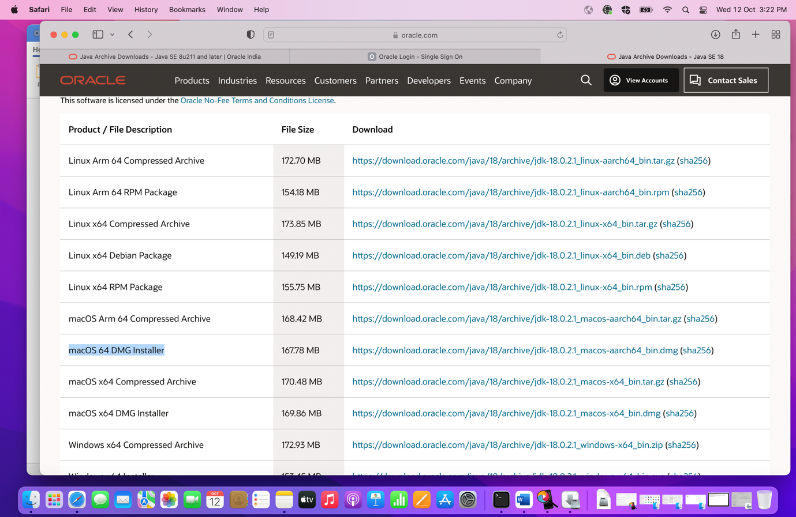

🡪Once it is downloaded, install the JDK.

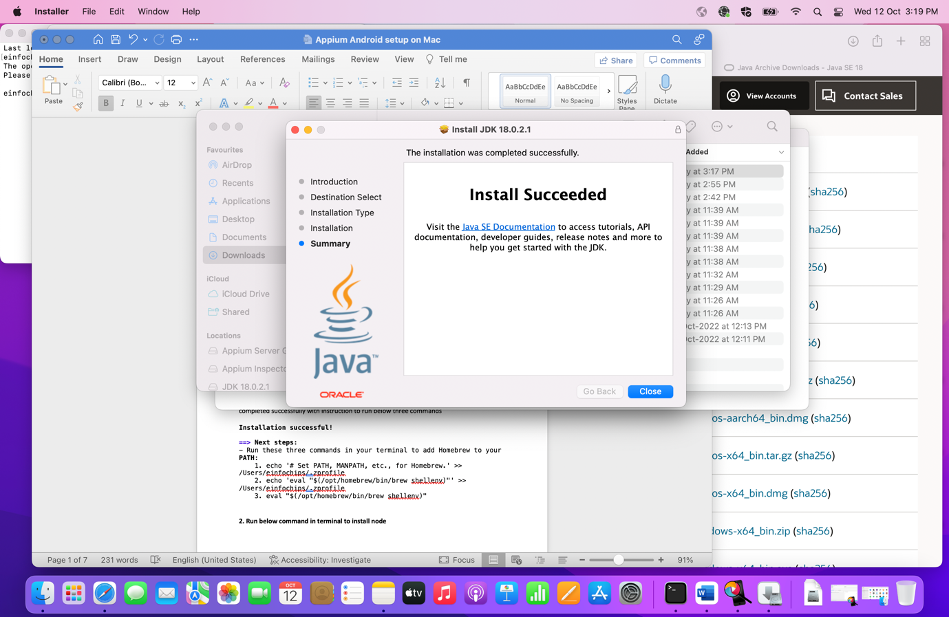

🡪Pop up is displayed for moving installer to Trash or bin folder. Move it to to Bin.

🡪Run the below command in terminal and check the version of Java

**🡪Run this:**

Java -version

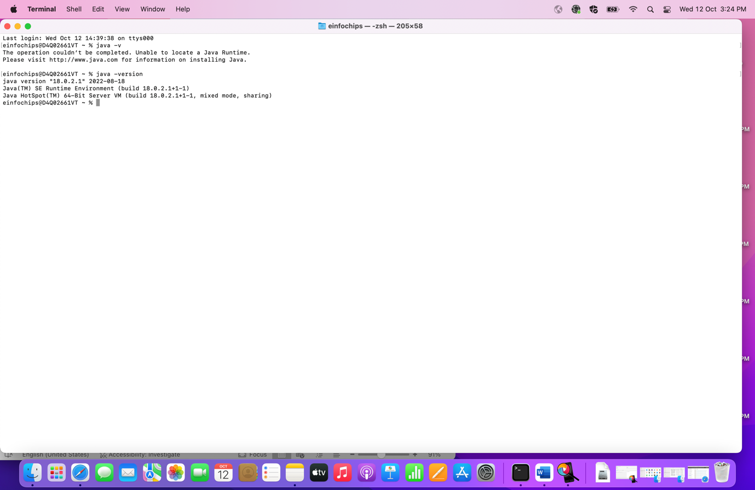

**Step 7: Install Appium doctor through the terminal by executing below command. (Appium Doctor is to diagnose and fix common Node, iOS and Android configuration issues before starting Appium.)**

**🡪Run this:**

npm install -g appium-doctor

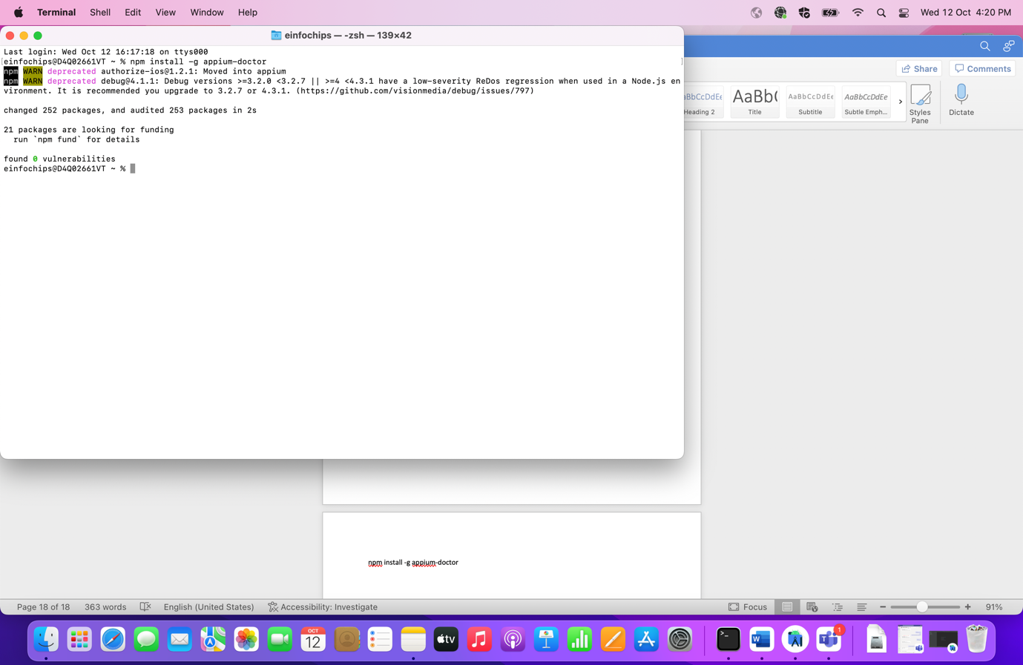

🡪We can check android setup

**🡪Run this:**

appium-doctor --android

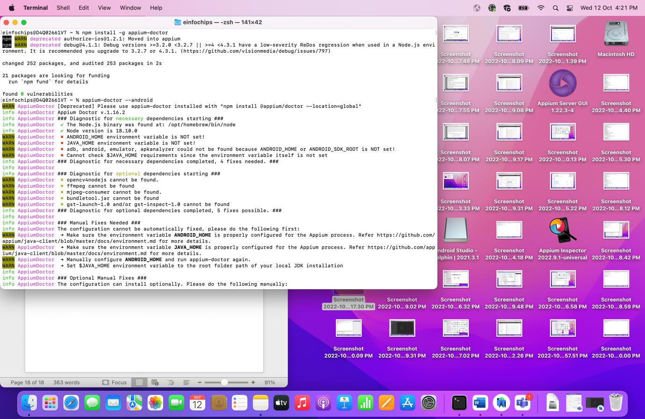

🡪We can see Java, Android and some other relevant details.

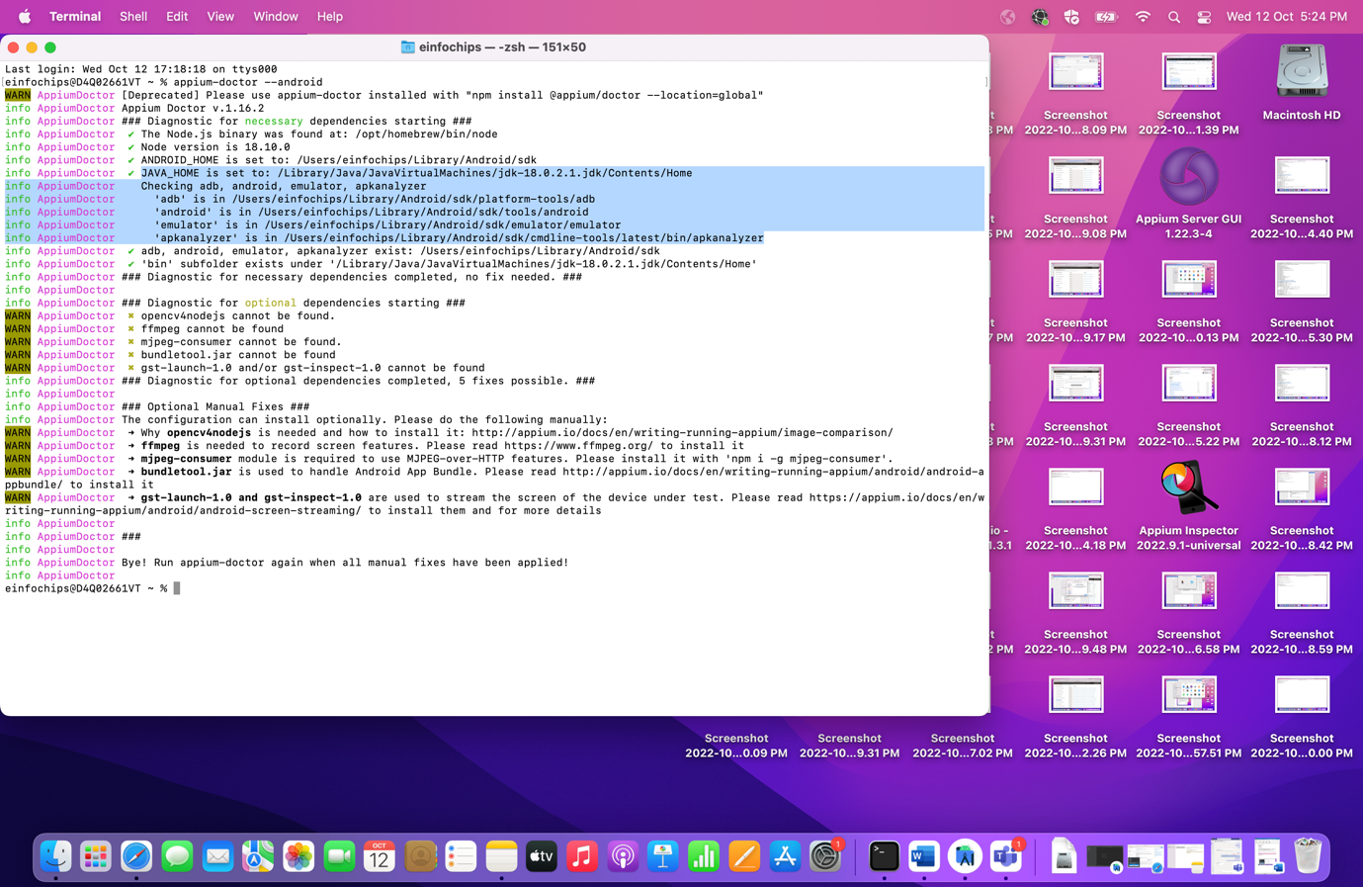

**Step 8: Set System Variable for Java and Android home**

🡪Open Terminal and run the below commands

1. cd ~/
2. touch .zprofile
3. open -e .zprofile

🡪So above three commands will navigate to home directory, then it will create and open zprofile where you can set system variable.

🡪set the below path in your zprofile box

export JAVA_HOME=/Library/Java/JavaVirtualMachines/jdk-18.0.2.1.jdk/Contents/Home

export ANDROID_HOME=${HOME}/Library/Android/sdk

export PATH="${JAVA_HOME}/bin:${ANDROID_HOME}/platform-tool:${PATH}"

🡪Once path is set, verify with below commands (Close your terminal and then after check by opening new Terminal otherwise it will display nothing)

**🡪Run these:**

echo $PATH

echo $JAVA_HOME

echo $ANDROID_HOME

This will give you the system variable contents.

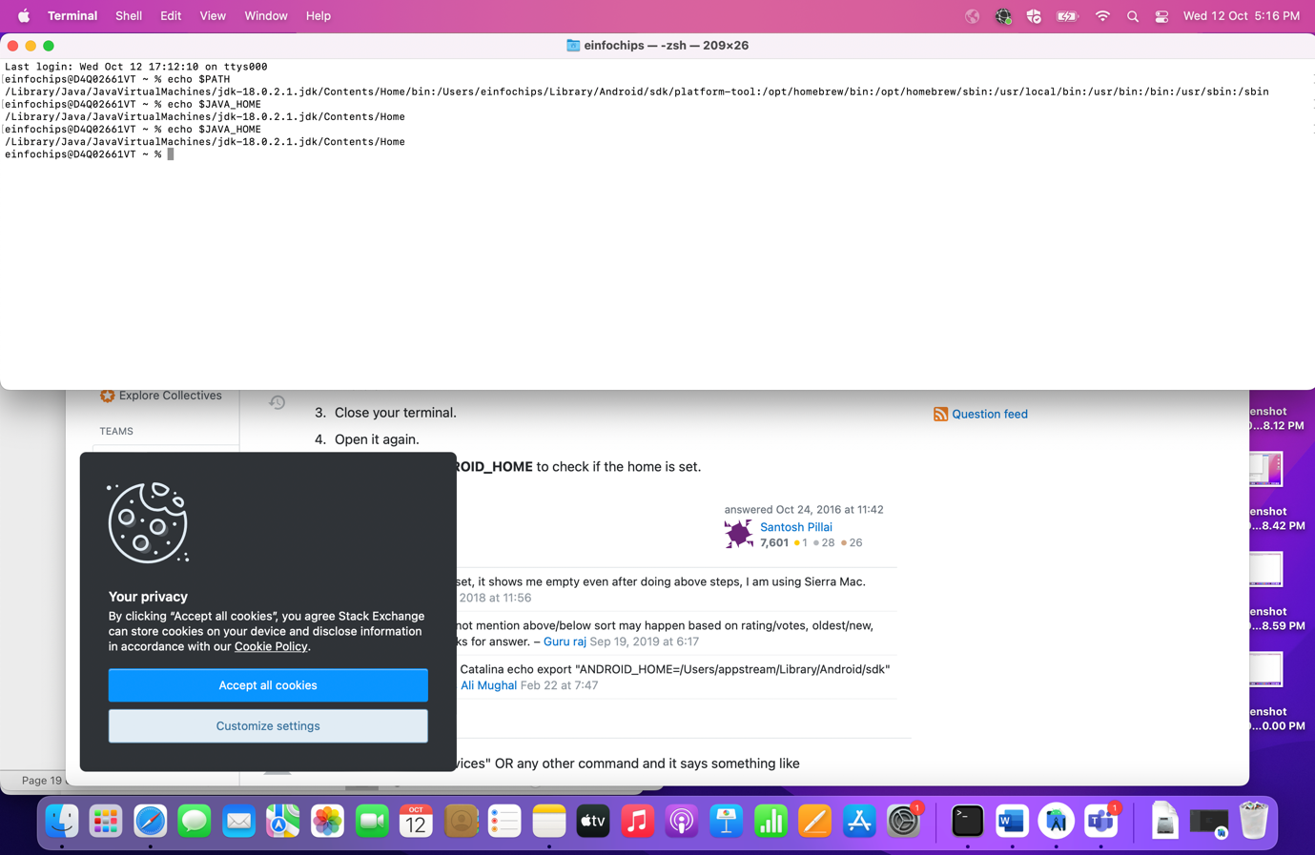

**Step 9: Install Xcode (Xcode is IDE – an integrated development environment – created by Apple for developing software for macOS, iOS, watchOS, and tvOS)**

🡪Go to System Preference and click on Apple Id

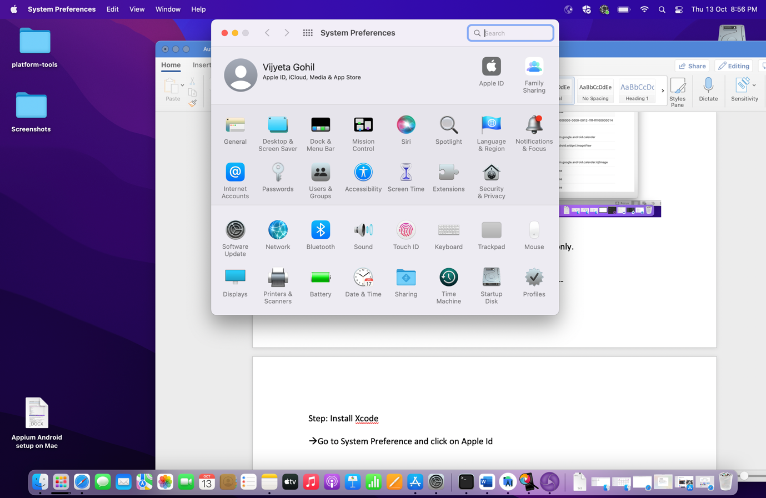

🡪If you are not logged in with Apple Id then login with all necessary steps (Password and two way authentication)

àOnce login step is completed, download the xcode (We can download xcode from the Apple Store and also from command line. If you want to go for specific version then directly download it from <https://developer.apple.com/documentation/xcode-release-notes/> )

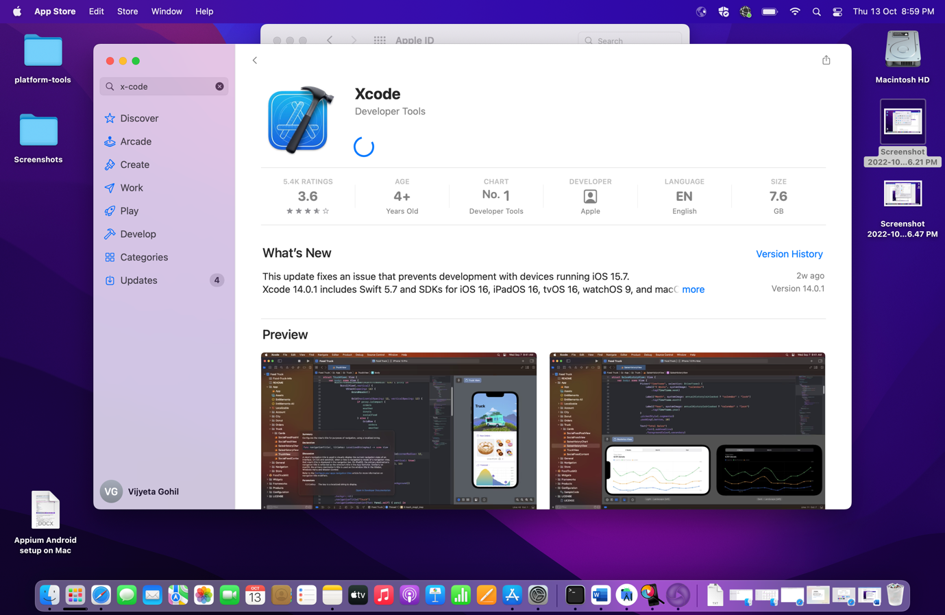

🡪If xcode is not downloaded from Apple Store, then follow the below step to download it from Terminal

**🡪Run this:**

Xcode -select –install

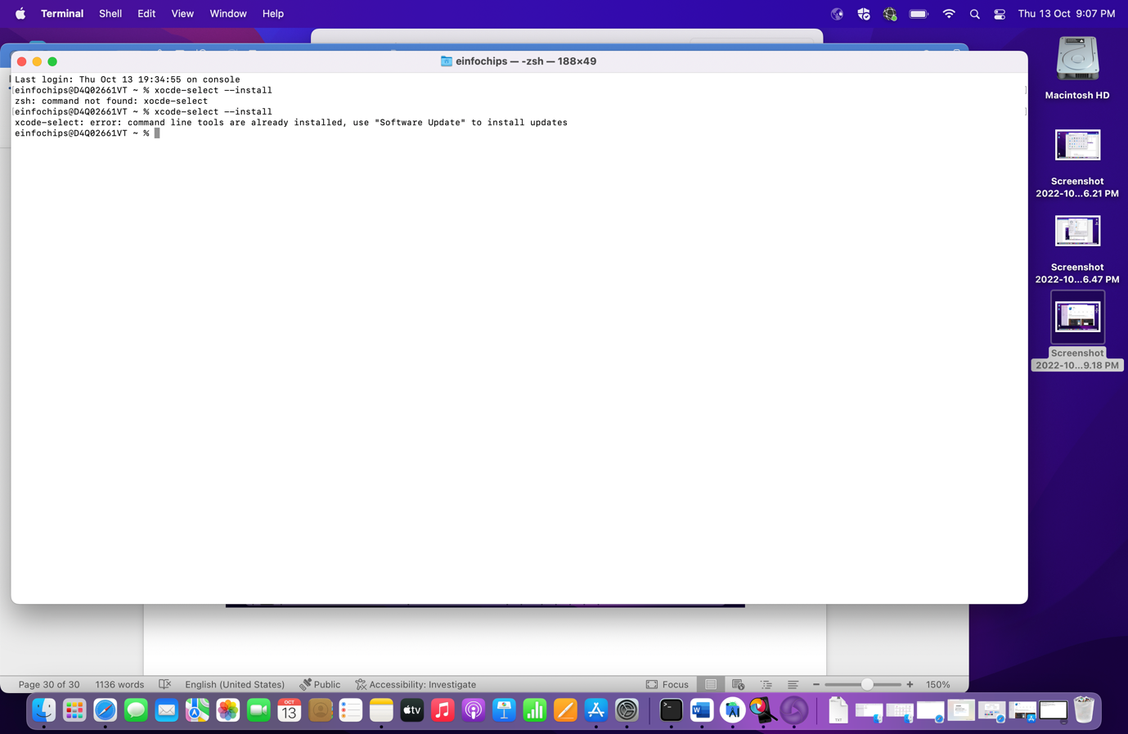

Note: We have already downloaded from Apple store hence error is displayed while executing the command

**Step 10: Install xcpretty (XCPretty is a fast and flexible formatter for xcodebuild which is used to make Xcode output reasonable)**

🡪Open the Terminal and run below command to install the xcpretty

🡪Run this:

**gem install xcpretty**

🡪If you get any access error then try with below command

**🡪Run this:**

Sudo gem install xcpretty

🡪After executing the command, it will ask for password. Give your system password (Password to login into the system)

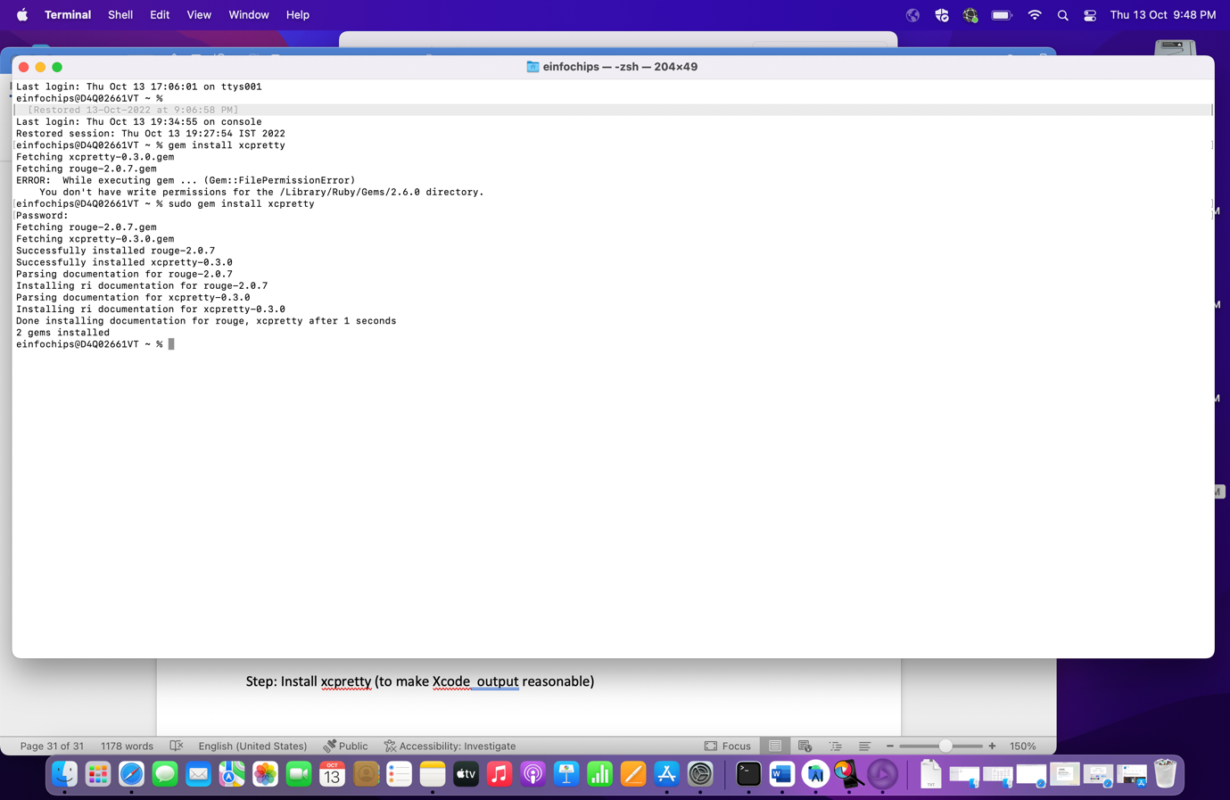

**Step 11: Install Carthage (Carthage is dependency manager and it is required for WebDriverManager)**

🡪Open Terminal and execute the below command

🡪**Run this:**

brew install Carthage

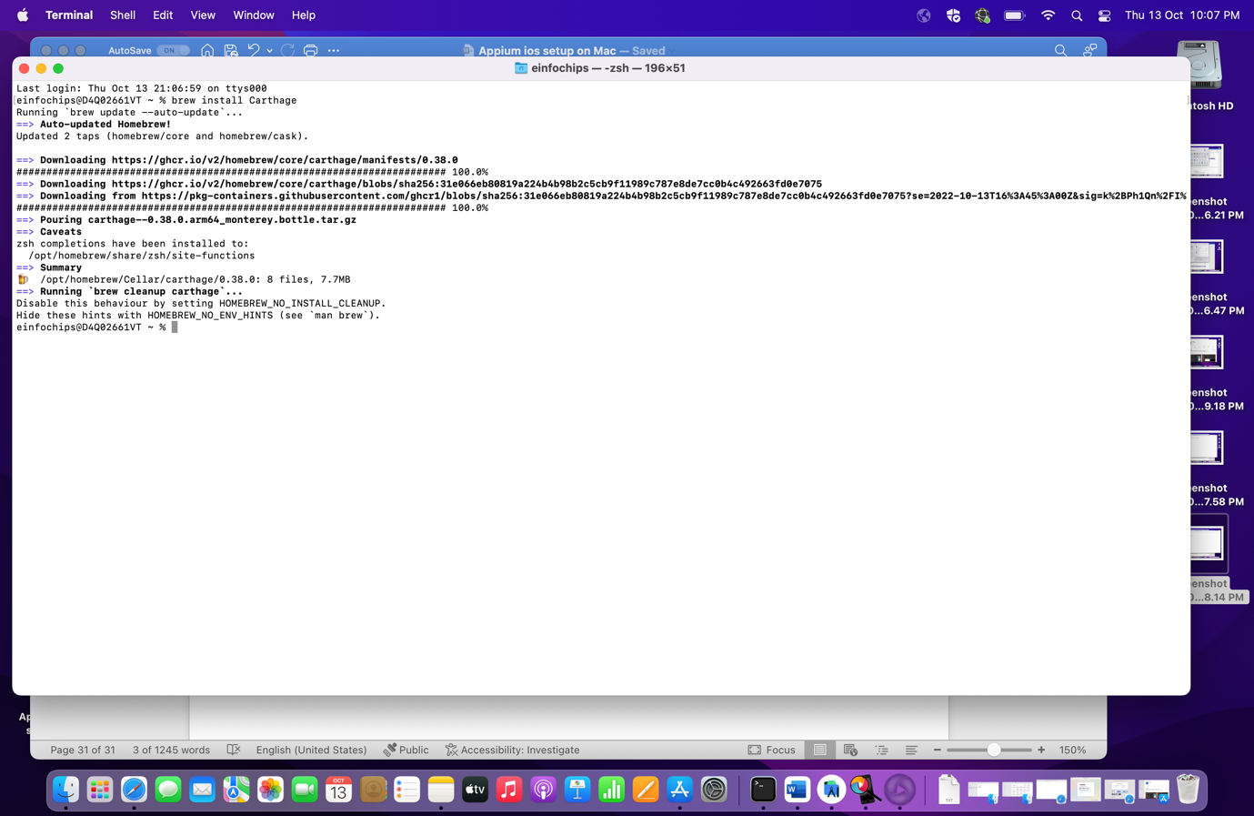

**Step 12: Build UIKitCatalog app for simulator and Real Device (UIKitCatalog app can work directly with simulator but for real device we need to go with its Bundle Id)**

🡪We need UIKitCatalog in our system and for that we need to download its code/project from github.

🡪To download the UIKitCatalog, clone project from below URL.

<https://github.com/appium/ios-uicatalog>

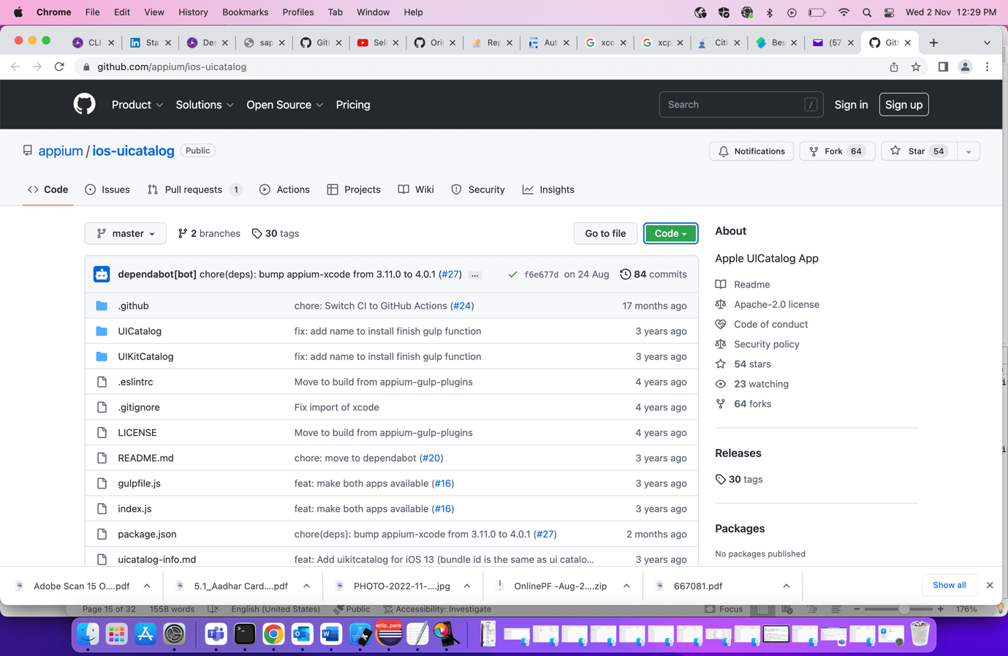

🡪Once you open the URL then after Go to Code-> Download ZIP folder.

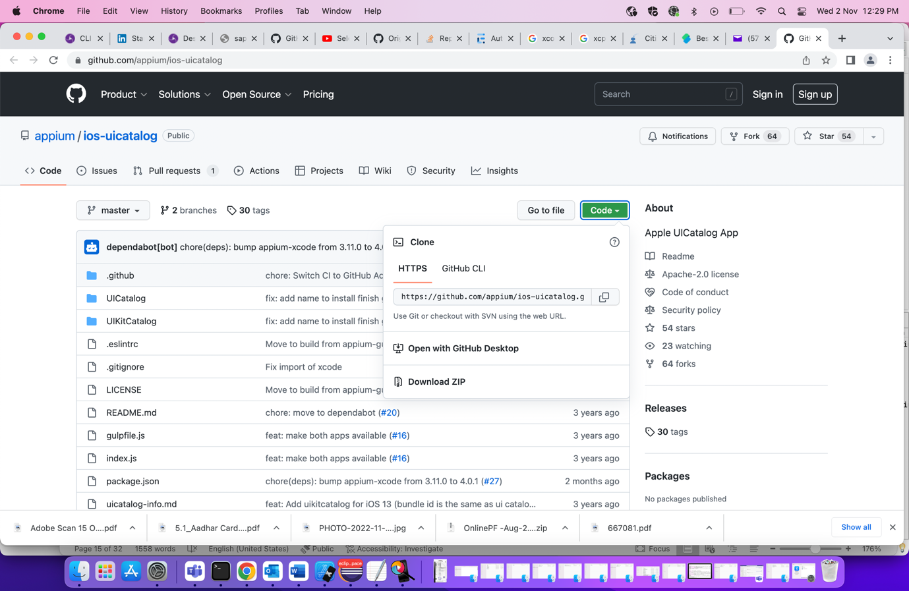

🡪Go to Download folder and check project is cloned correctly or not.

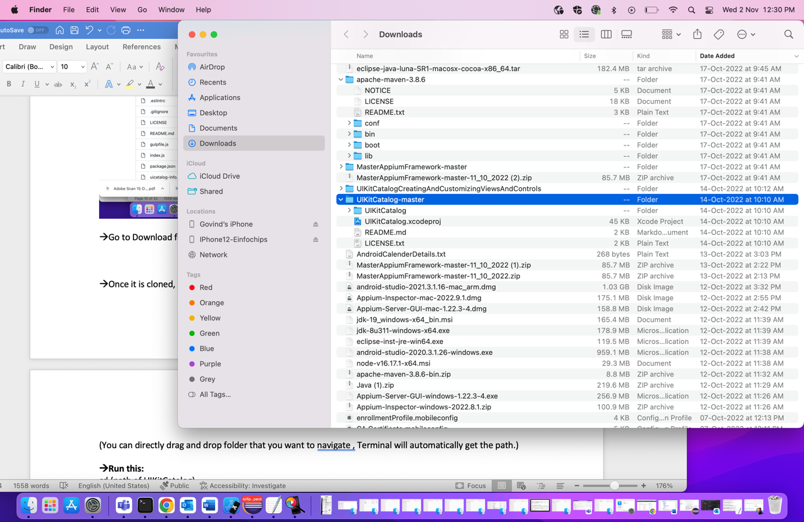

🡪Once it is cloned, Open the Terminal, go to the path where you have placed your project

(You can directly drag and drop folder that you want to navigate , Terminal will automatically get the path.)

**🡪Run this:**

cd (path of UIKitCatalog)

for my machine, path is set as : cd /Applications/ios-uicatalog-master/UICatalog

🡪once your dictionary is changed, run below command

🡪Run this:

npm install

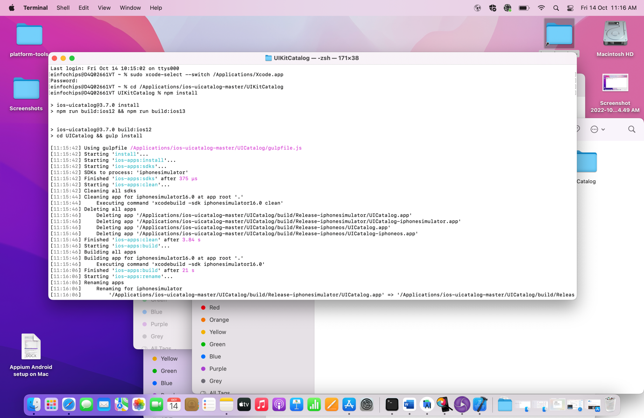

🡪If you face any issue regarding Xcode as shown in below document, then try below steps

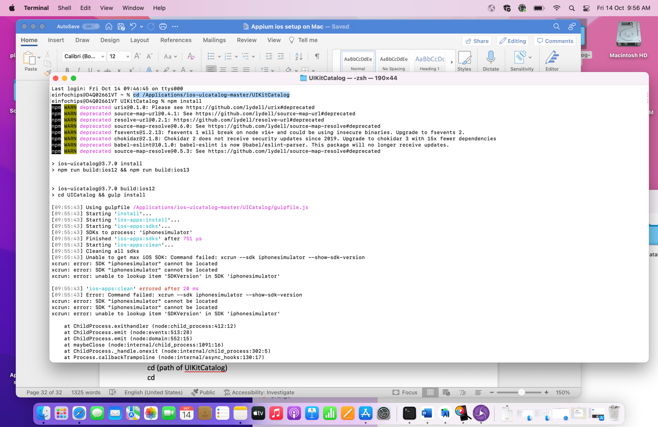

🡪**Run this:**

sudo xcode-select --switch /Applications/Xcode.app

🡪If you have installed Xcode app in a different location, give that path instead of /Applications/Xcode.app.

🡪Once installation is completed , check files at below path

Path: Go to your project folder ->build->Release folder

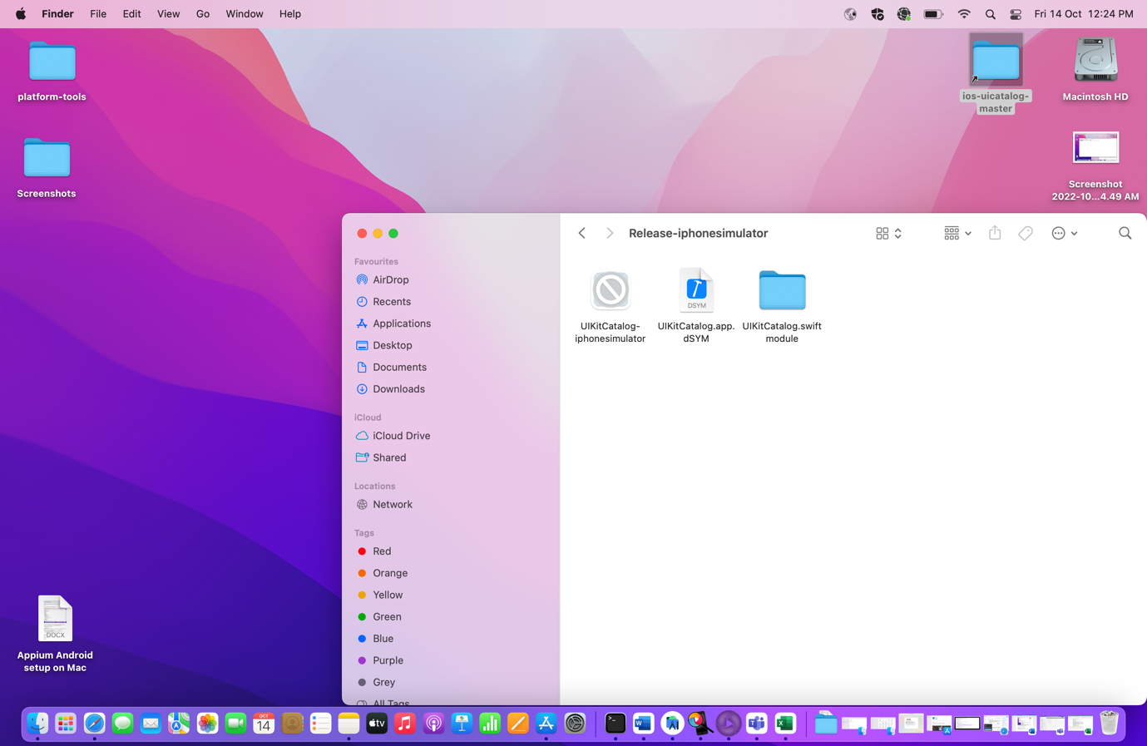

🡪Check this app is working on your simulator (Give path where you have placed your UIKitCatalog project ad go till you get UIKitCatalog.app file)

Prerequisite: Appium server should be running.

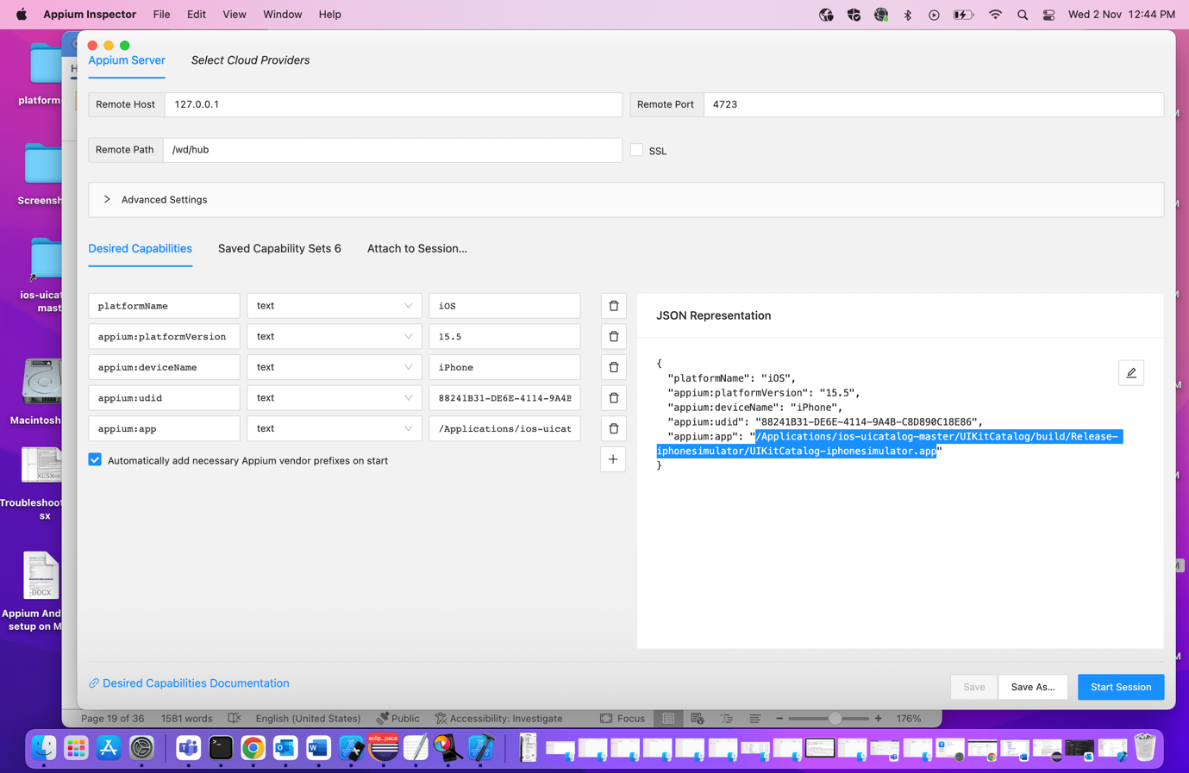

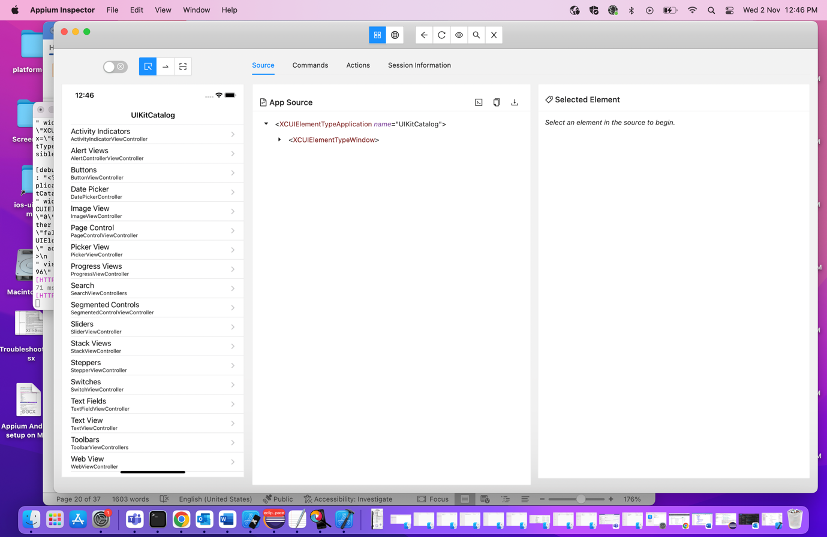

**Step 13: Xcode WebdriverAgent setup (WebDriver agent will work as proxy between apple framework and driver)**

This is fully manual configuration for free Apple Developer account that we can setup and test real devices.

Step 1. Add your Apple ID to XCode and download the certificate.

🡪Follow the below screenshots and open your Xcode and download the certificate.

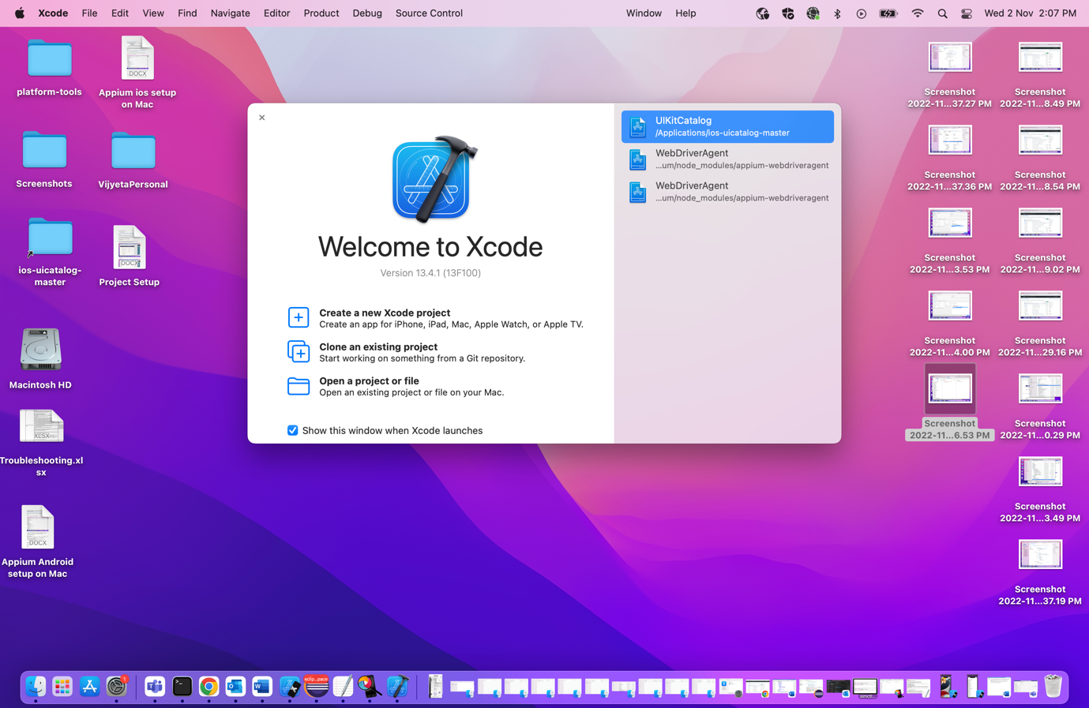

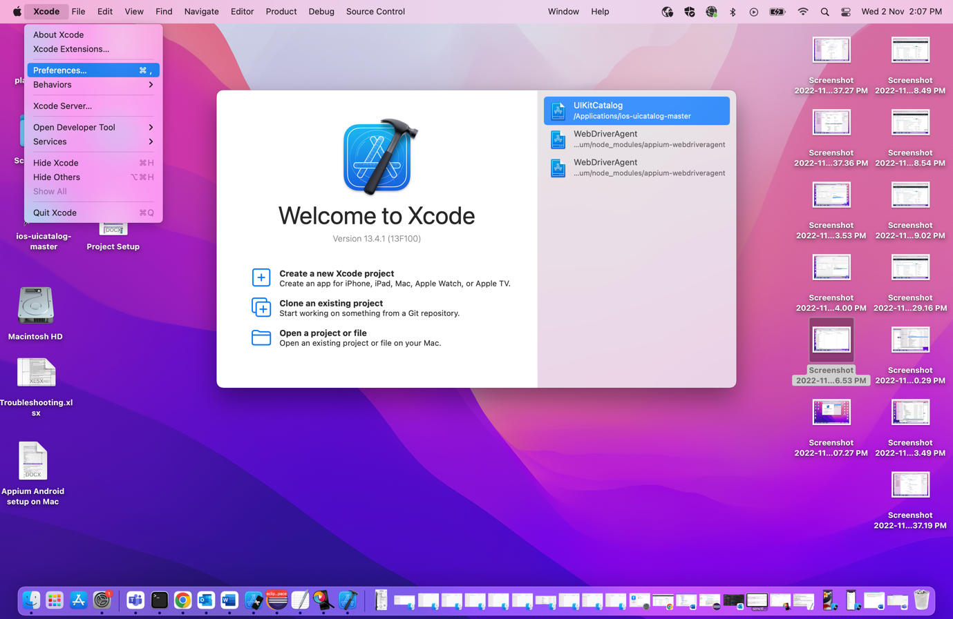

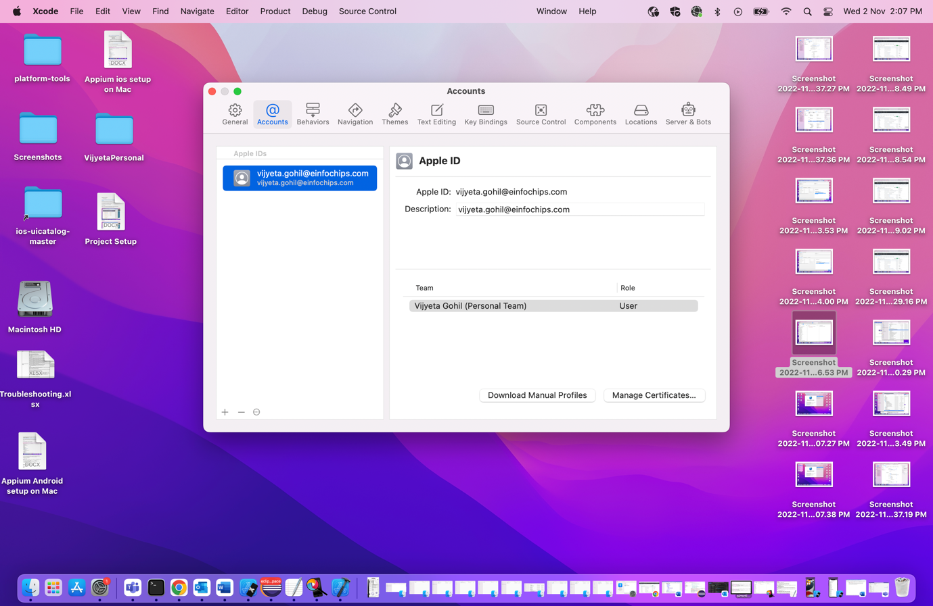

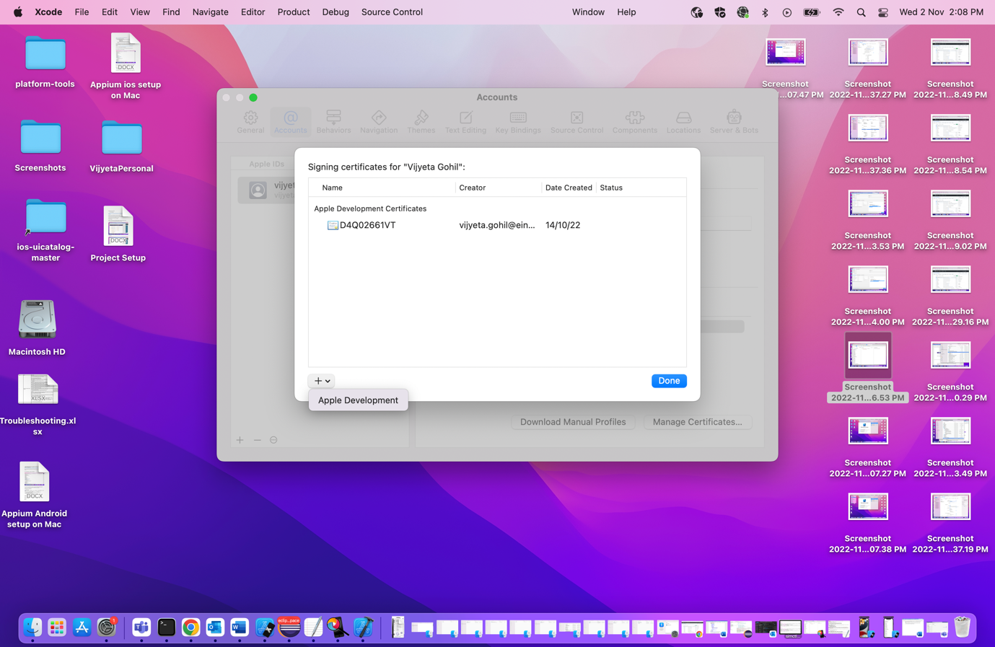

🡪So by above steps you are able to download your certificate

Step 2. Find WebDriverAgent project

🡪We will use Appium CLI version for test execution and point Appium Desktop to use CLI server for inspecting the app.

🡪Open terminal and execute below command to get the path of Appium:

**🡪Run this:**

where appium

or

which Appium

🡪This will give you path of Appium from CLI.

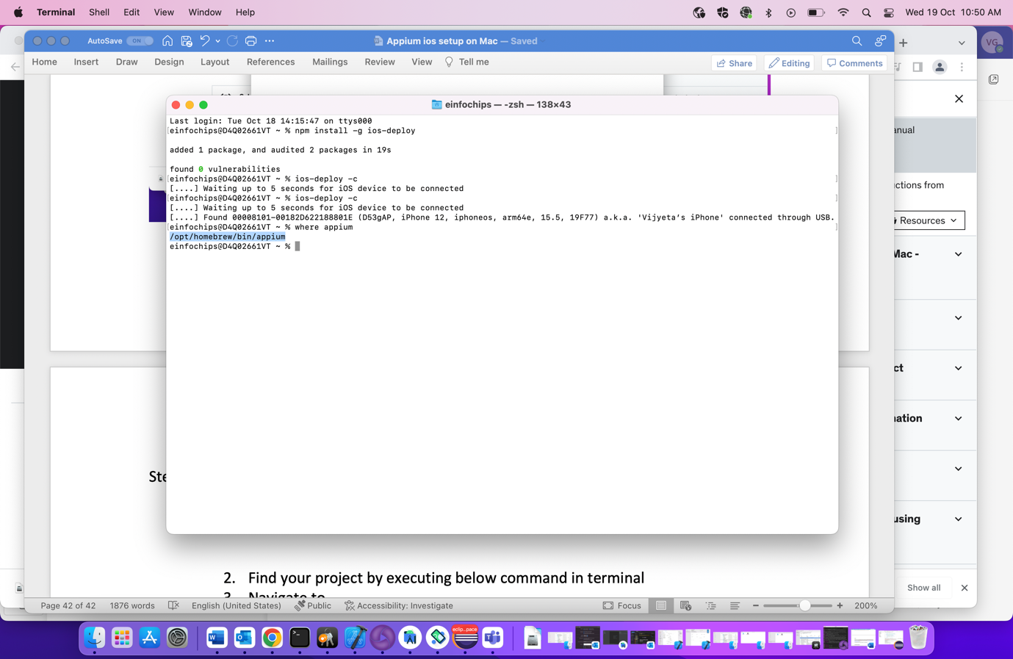

WebDriverAgent project path:

Appium CLI:

/opt/homebrew/lib/node_modules/appium/node_modules/appium-webdriveragent

🡪 We can also search WebdriverAgent from Desktop. Follow the below structure

Appium Desktop: /Applications/Appium.app/Contents/Resources/app/node_modules/appium/node_modules/appium-webdriveragent

🡪We are going to use CLI so we are following that folder structure and to go that structure open Finder and from top side menu bar go to Go-> Go to Folder

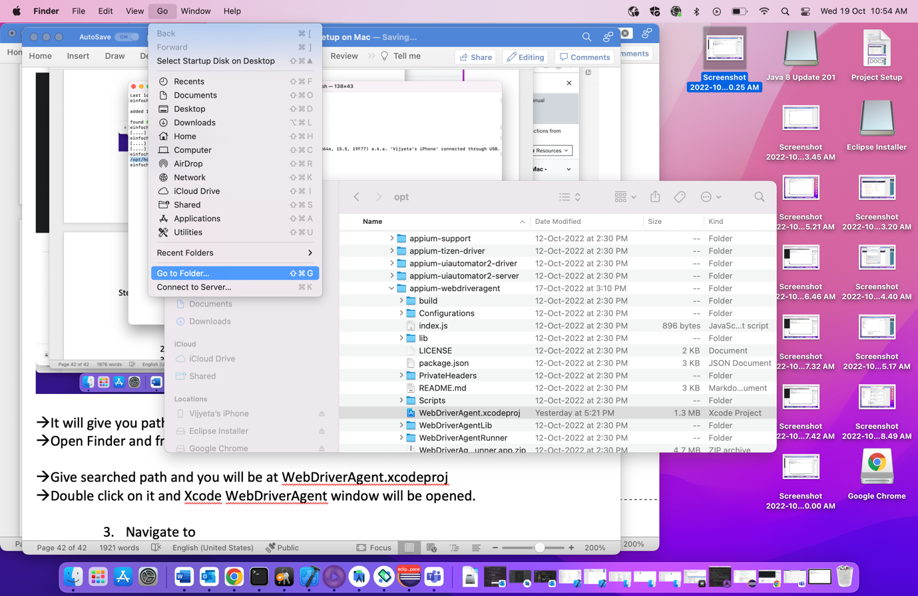

🡪Give searched path and you will be at WebDriverAgent.xcodeproj

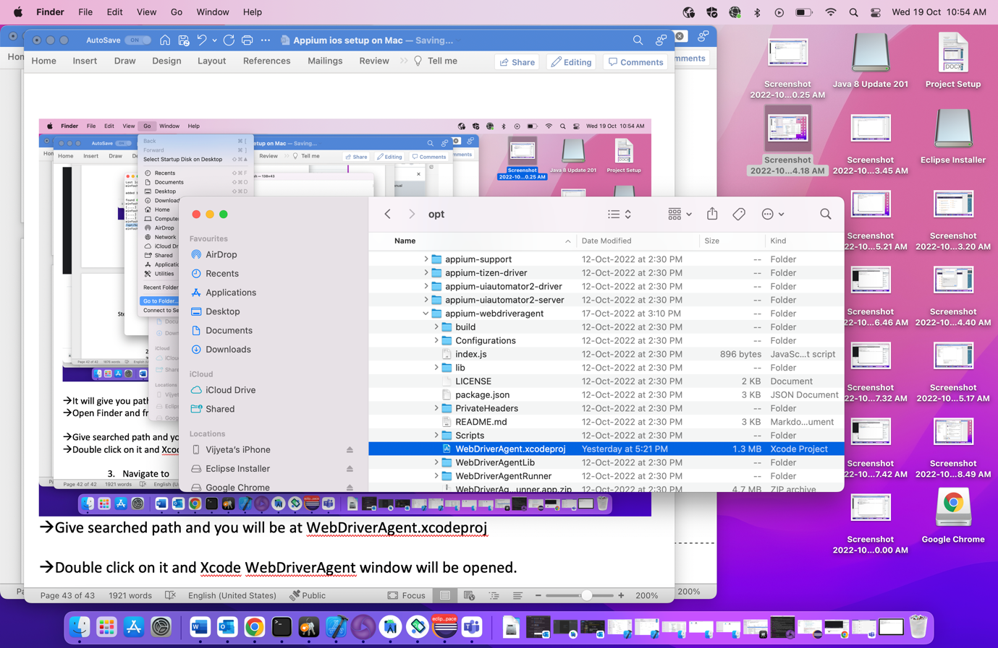

🡪Double click on it and Xcode WebDriverAgent window will be opened.

🡪 We are doing this activity for real devices attached to your mac.

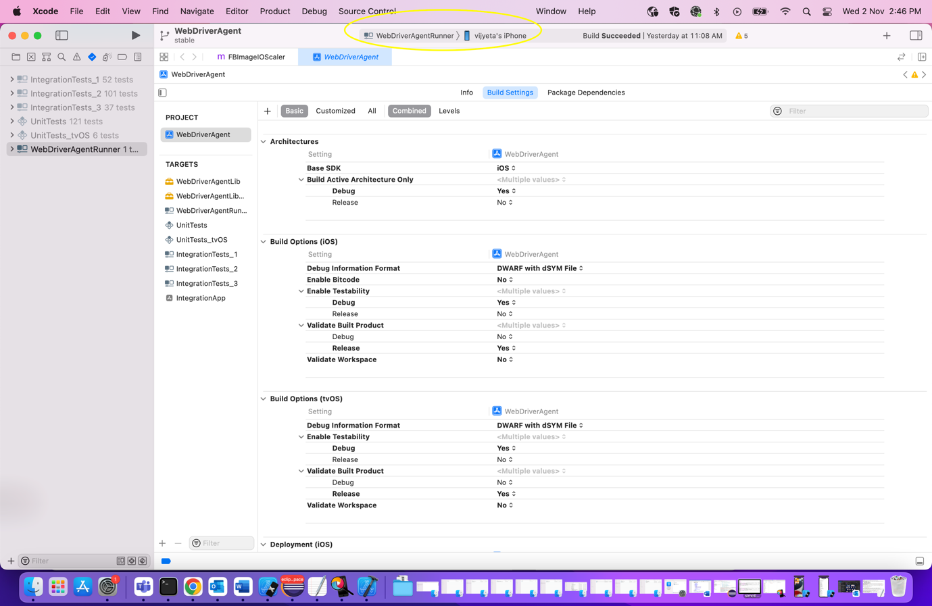

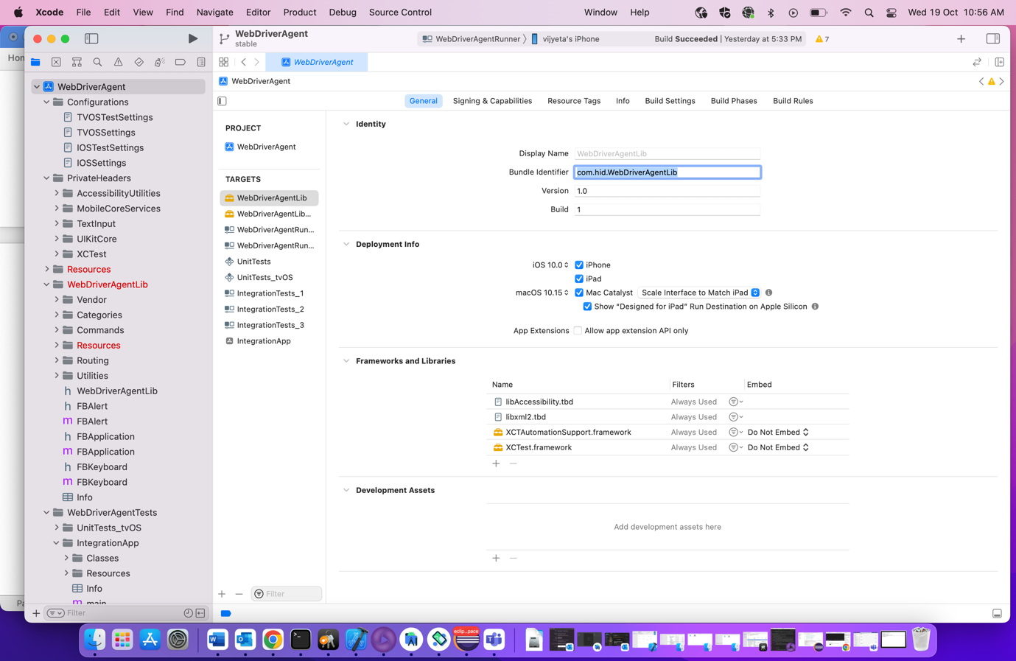

🡪 Click on WebDriverAgent from left side menu then select WebDriverAgentLib from Project Tab

🡪Now we wiil check Bundle Identifier for few fields and those are WebDriverAgentLib, WebDriverAgentRunner and Integration App.So let’s start with WebDriverAgentLib

🡪Verify that “Automatically manage signing checkbox should be checked and give unique Bundle Identifier

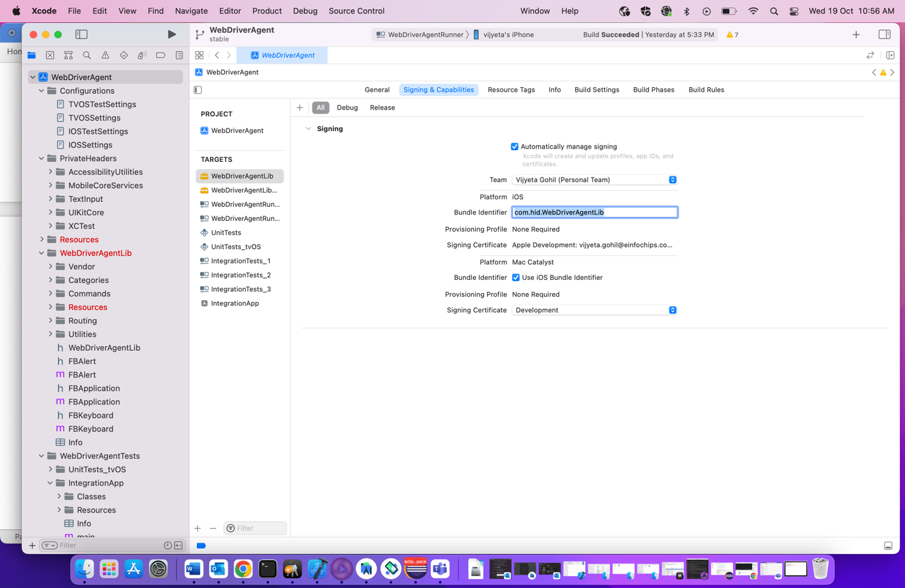

🡪Go to Build Setting 🡪Packaging🡪Product Bundle Identifier 🡪Give same bundle identifier that gives before

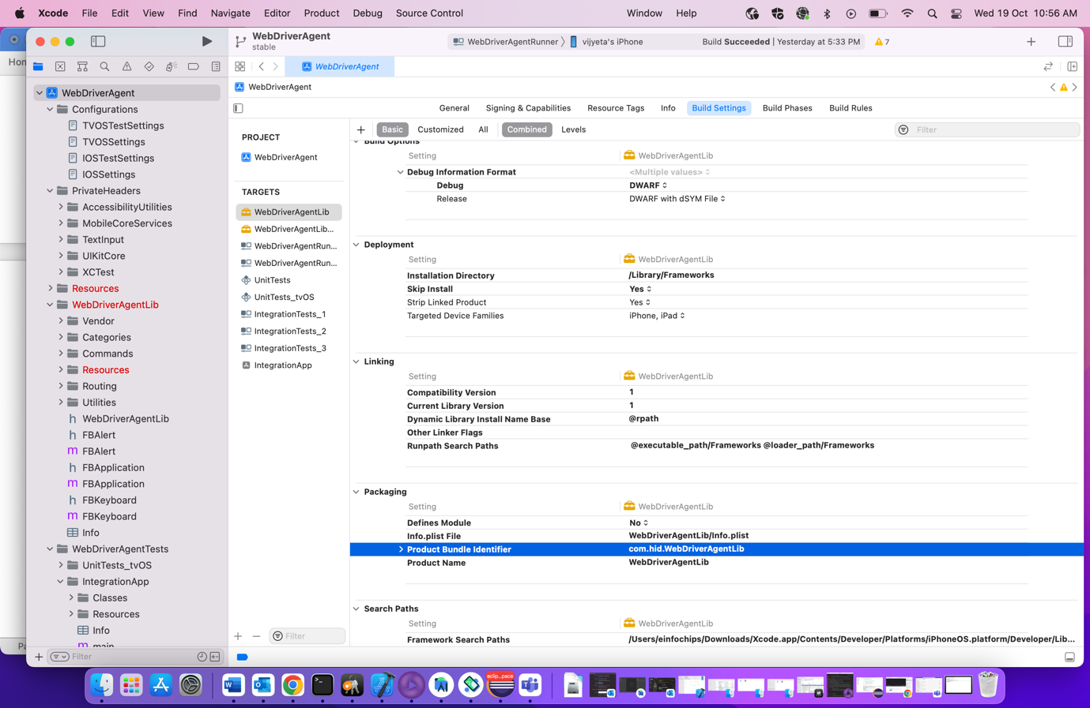

🡪Go to WebDriverRunner and check for General, Signing and Capabilities and Build Setting and change Bundle Identifier value.

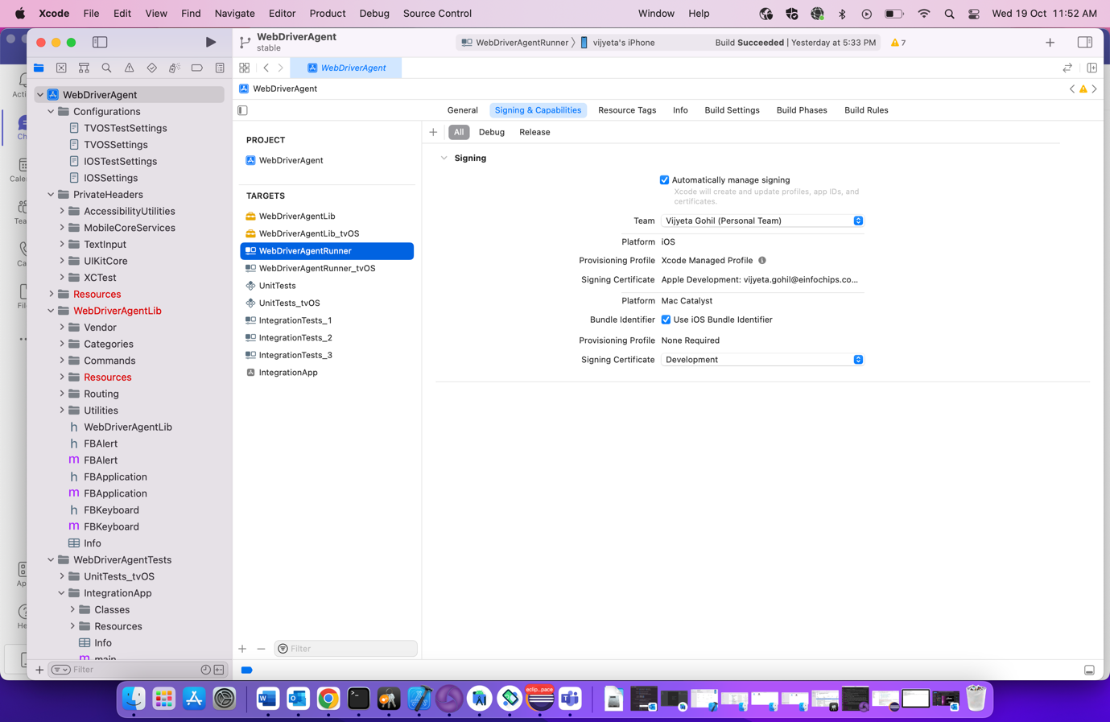

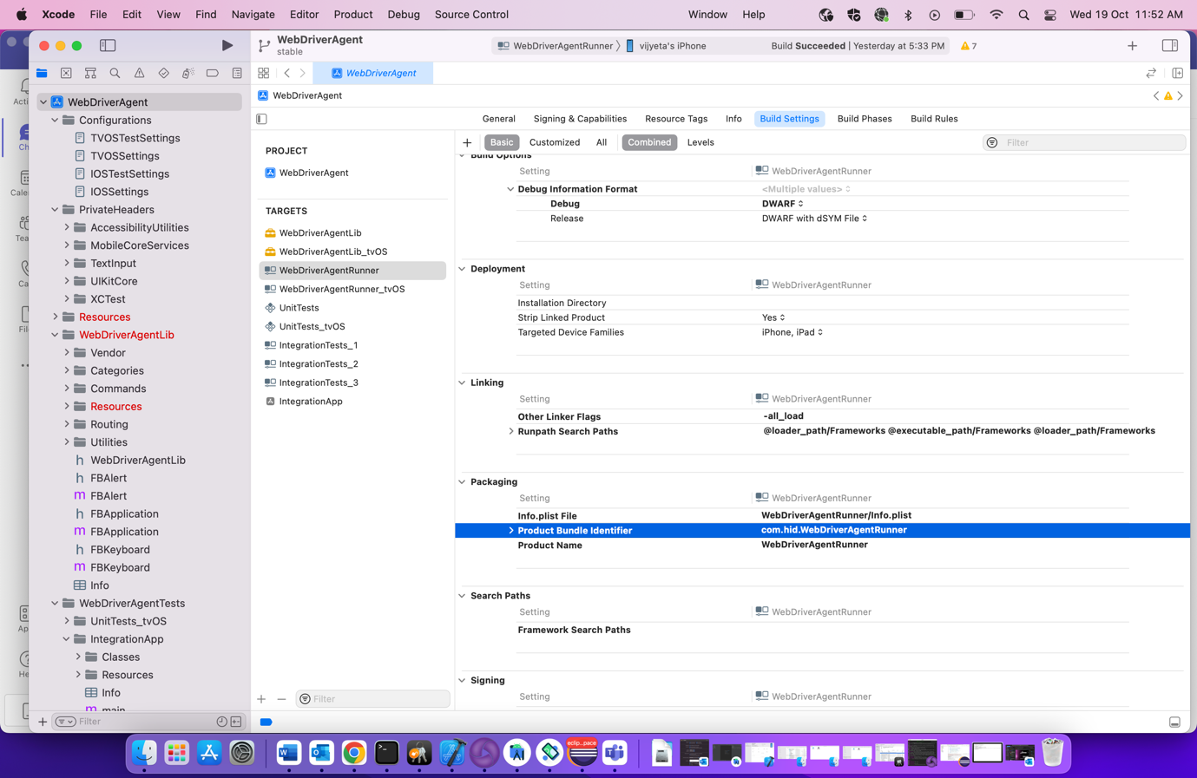

🡪Go to IntegrationApp-> Signing and Capabilities and check the bundle identifier. It should be same as given in different Tab

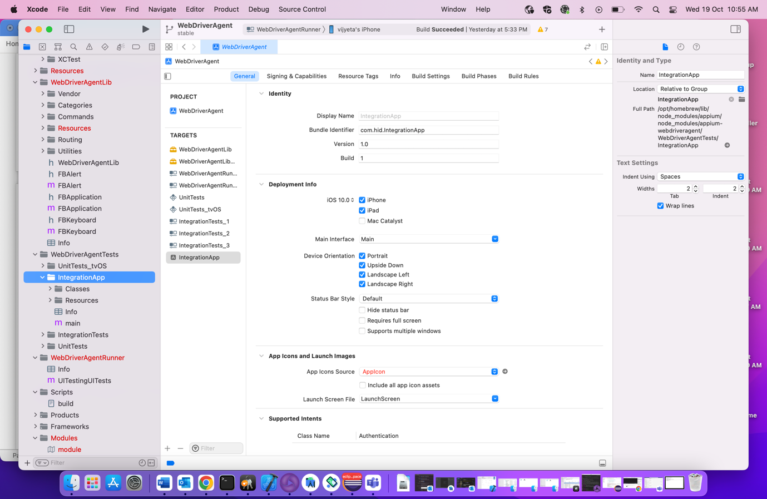

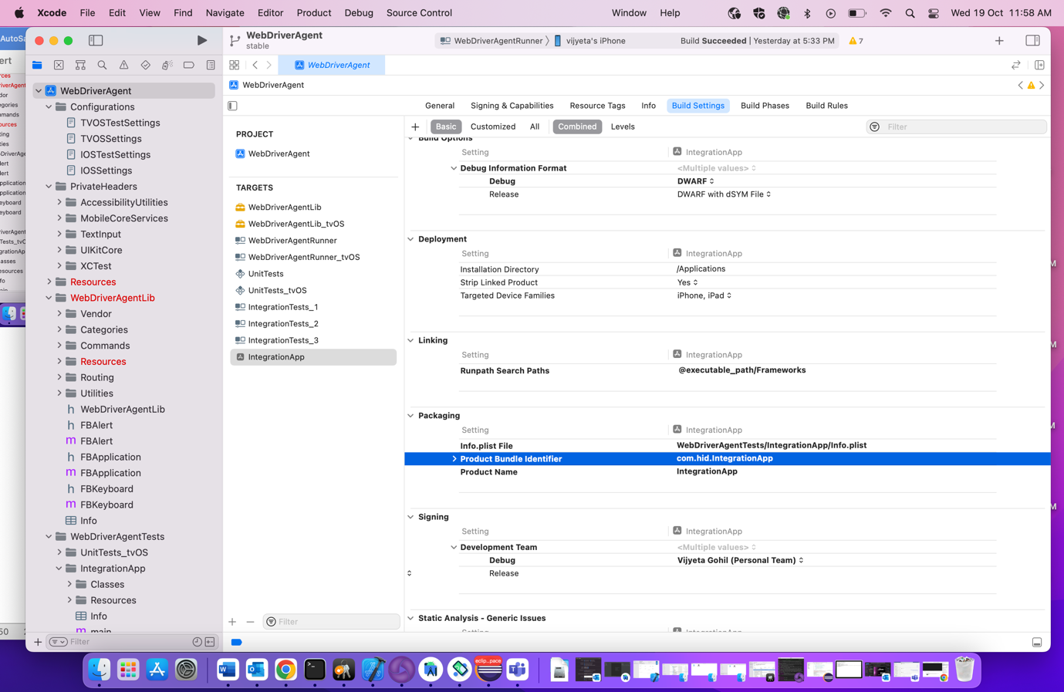

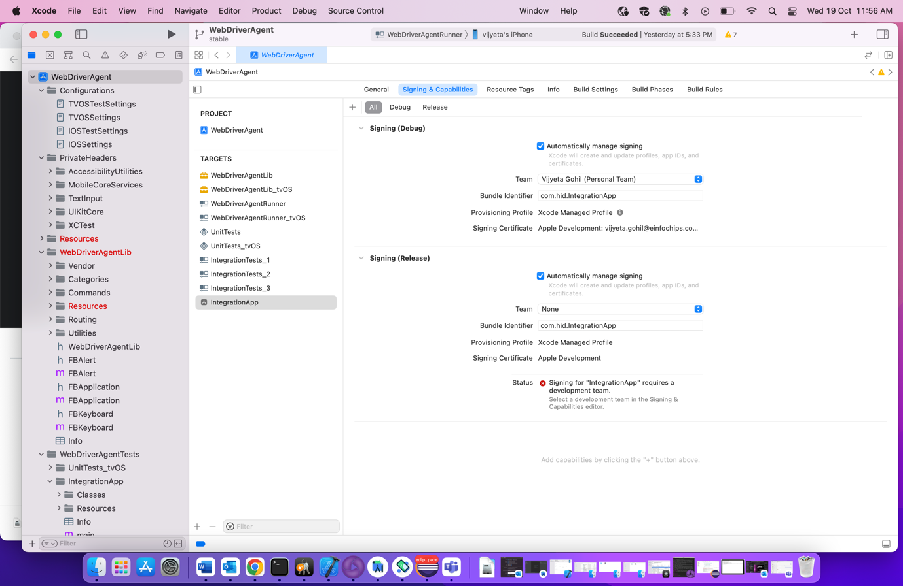

🡪Now Go to Project from menu and click on Clean Build Folder

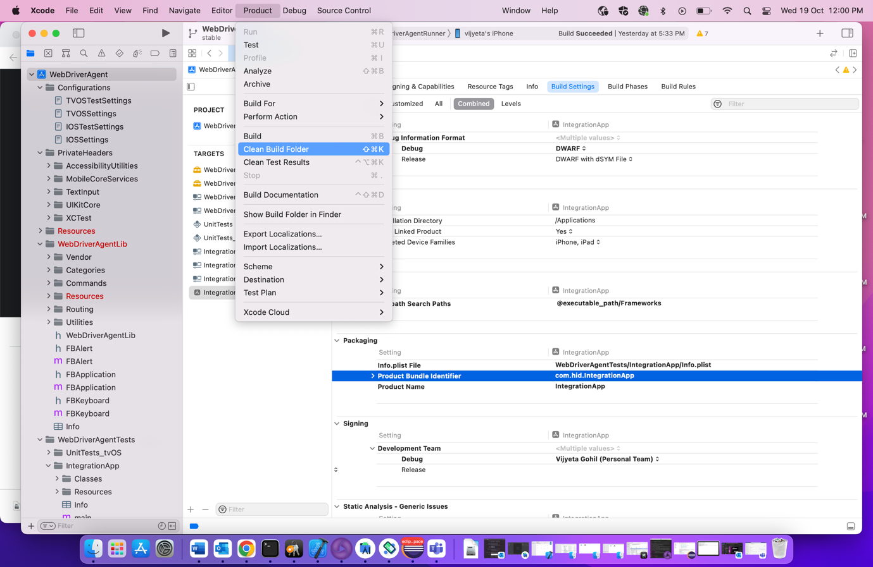

🡪Click on Build now

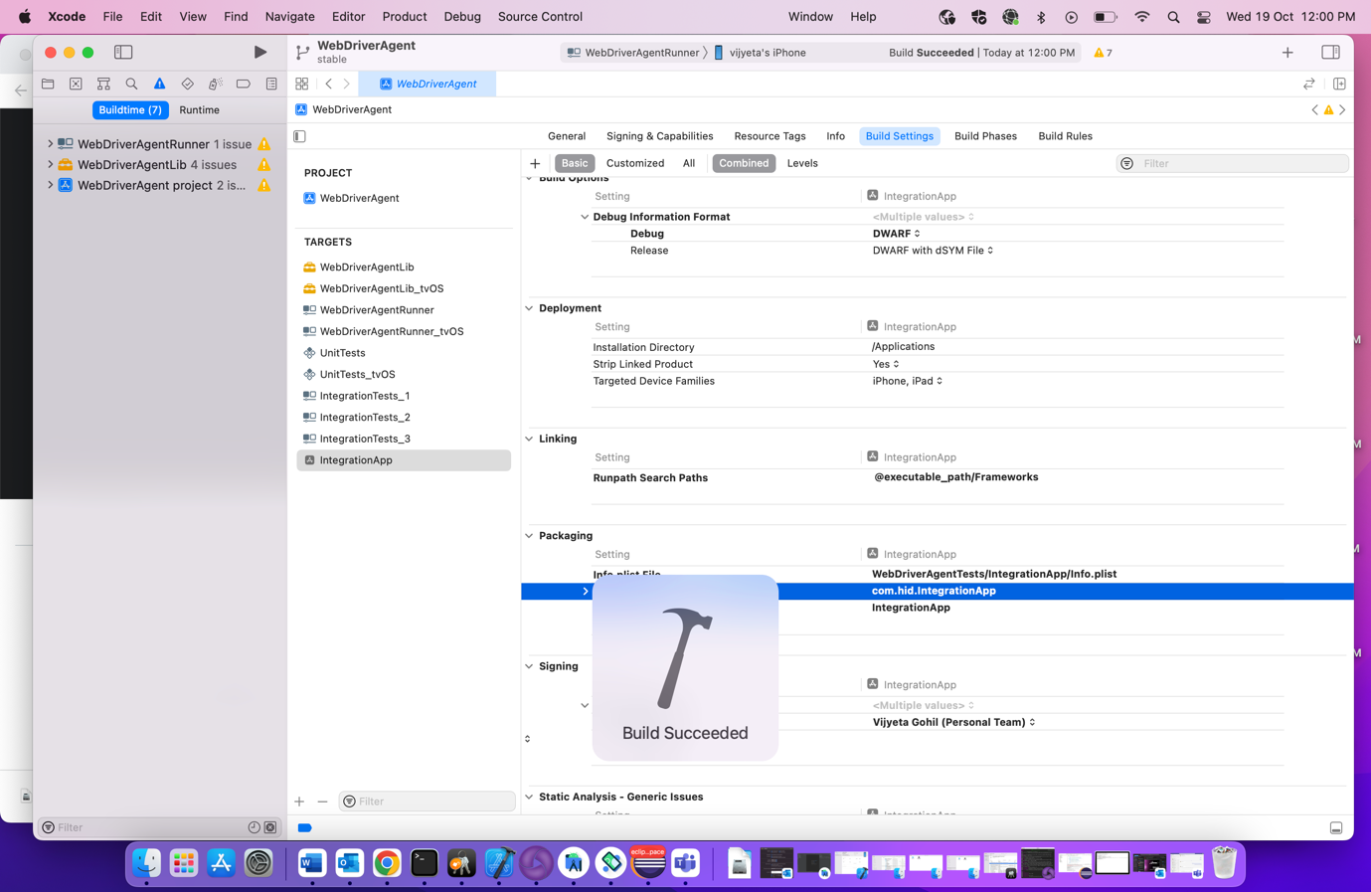

🡪Now build is succeeded.

🡪We need to one more step in our phone and that is trust the certificate so for that

Go to Setting🡪General🡪VPN and Device Management🡪Trust the Certificate

Otherwise you may get the below error (Make sure your mobile is connected with wifi or mobile data is on)

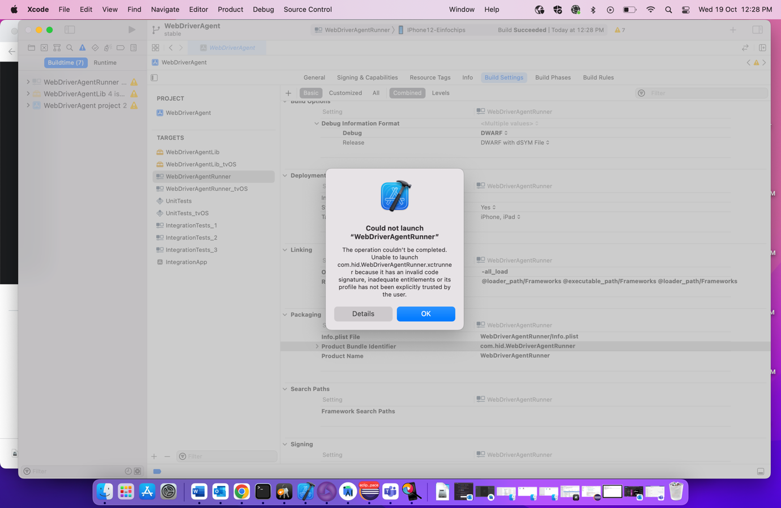

🡪Solution of above issue:

#### Trust Developer from iPhone Settings

Once the command in step 8 is executed, we can Trust the developer from the iPhone settings. Settings →  General → Device Management and "Trust" yourself as developer.

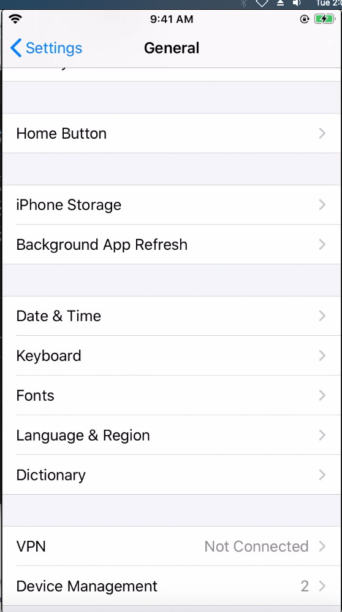 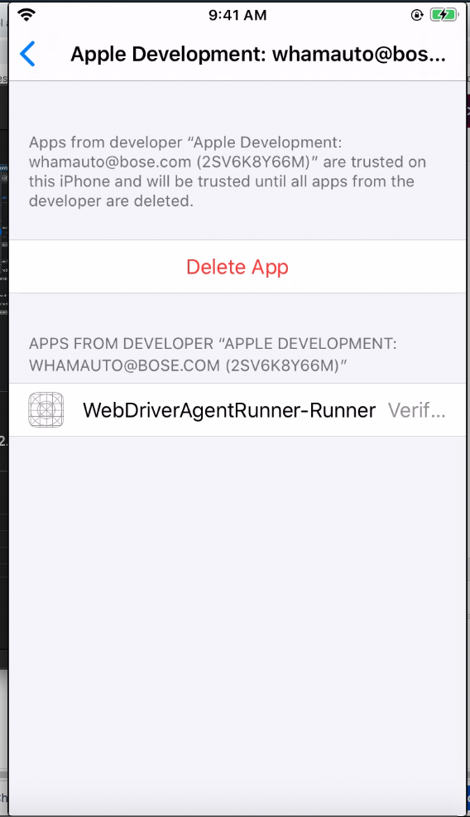

🡪Now try to test it. Go to Project->Test (your pointer should be at Runner)

🡪 Now the Test will be passed.

**Step 14: Real Device Setup**

Getting UDID

🡪For gettingUDID, we need to run few commands as a prerequisite.

1. Command to ios-deploy

🡪Run this:

npm install -g ios-deploy

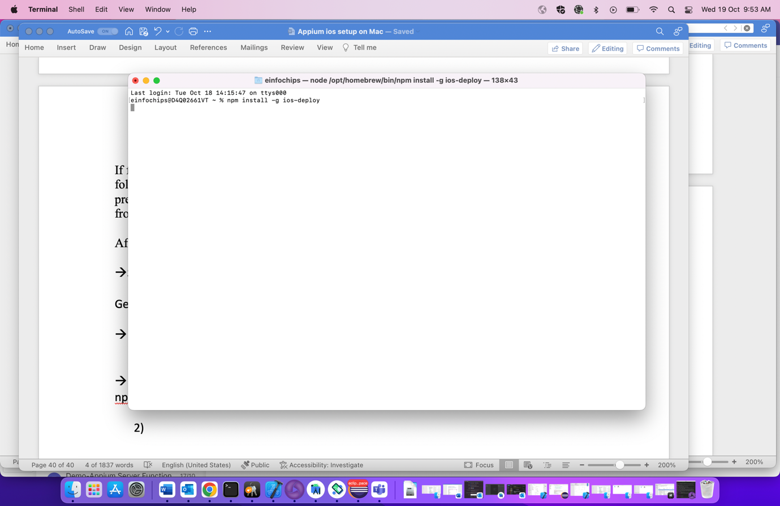

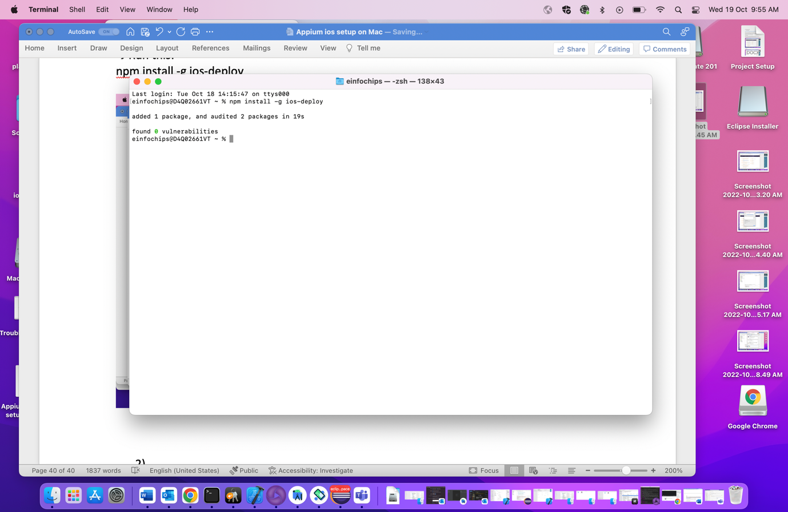

1. Command to get UDID

🡪Run this:

ios-deploy -c

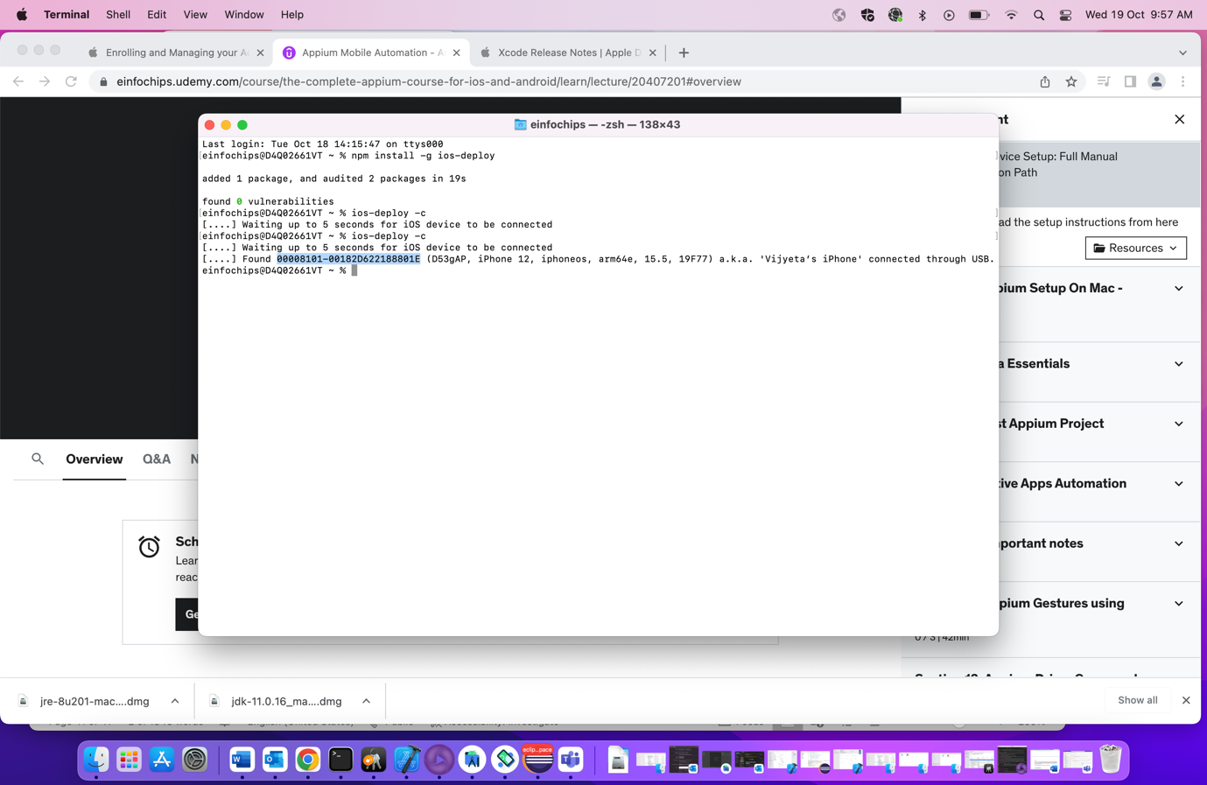

**Step 15: Build a project on real device**

🡪Open Terminal and execute the below command in Terminal

🡪Run this:

xcodebuild -project WebDriverAgent.xcodeproj -scheme WebDriverAgentRunner -destination 'id=<udid>' test -allowProvisioningUpdates

🡪For Example

xcodebuild -project WebDriverAgent.xcodeproj -scheme WebDriverAgentRunner -destination 'id=00008101-00182D622188801E' test -allowProvisioningUpdates

**Step 16: Set BundleId in UIKitCatalog app**

🡪 For real device, with free Apple Developer account we cannot get UIKitCatalog.ipa file which is needed as capability so for alternate way we can have bundle Id which will be used instead.

🡪Go to UIKitCatalog Xcode and open it.

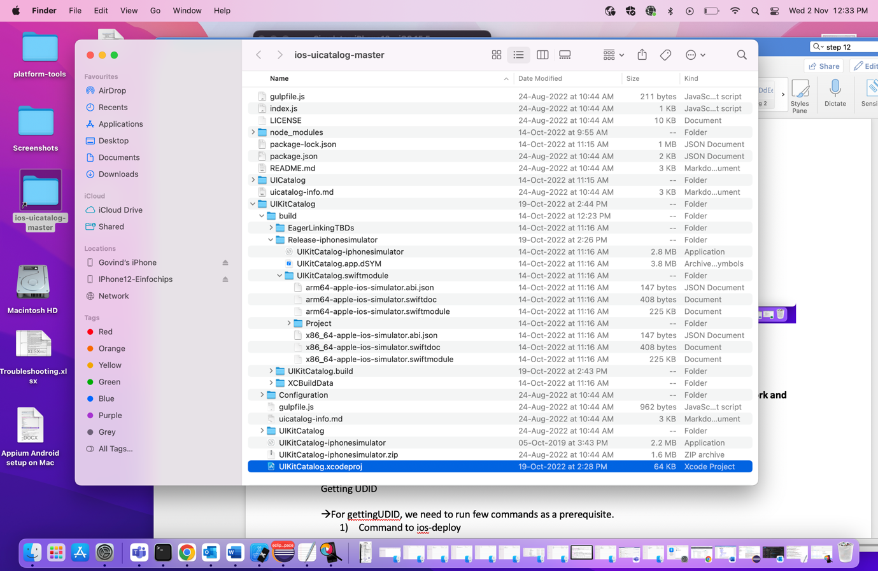

🡪For General, Signing & Capabilities and Build Setting, we need to select unique Bundle Identifier.

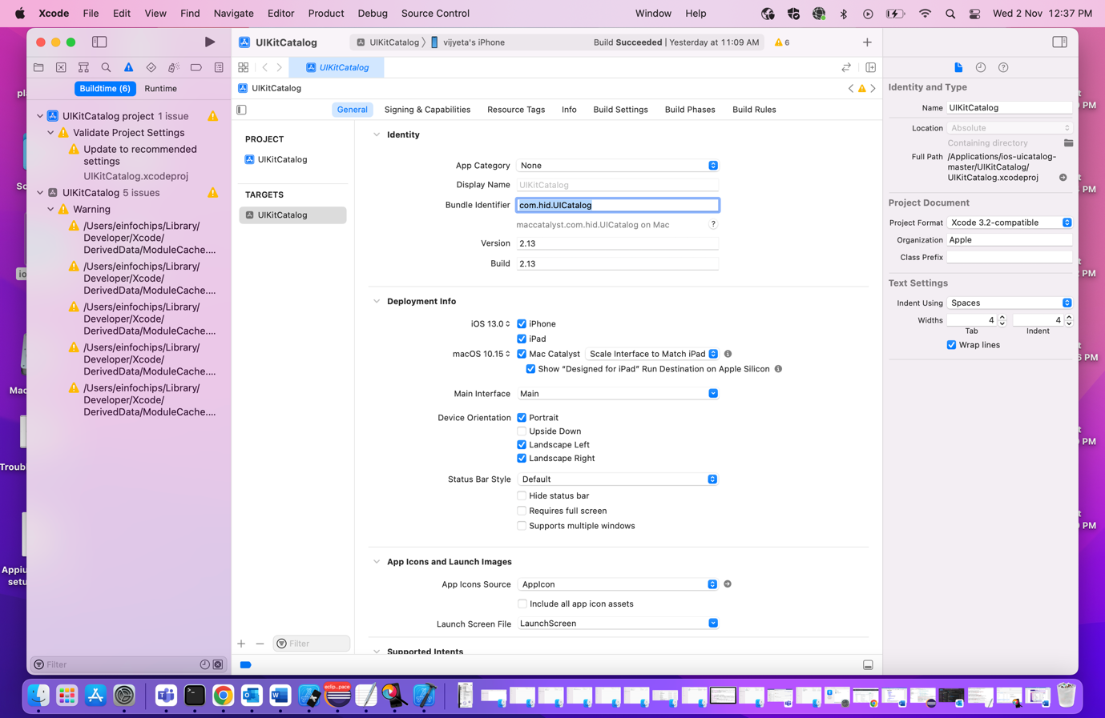

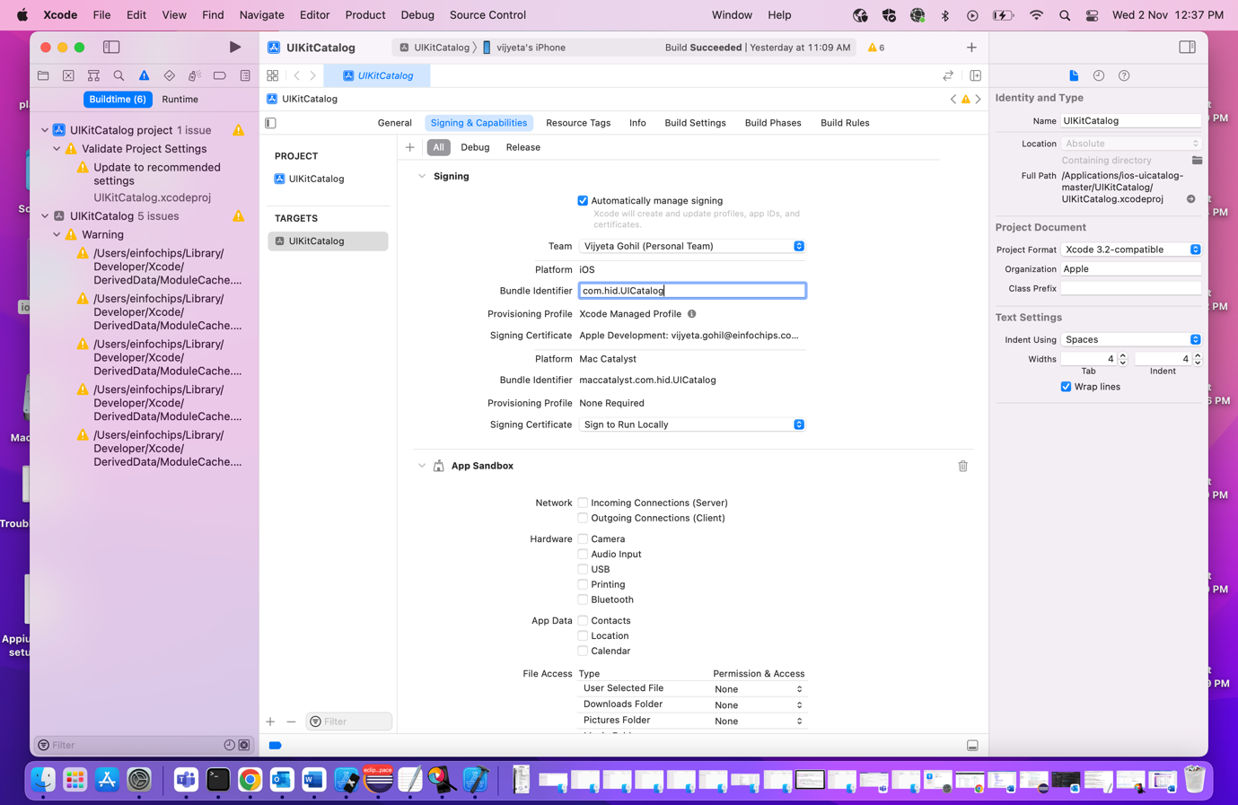

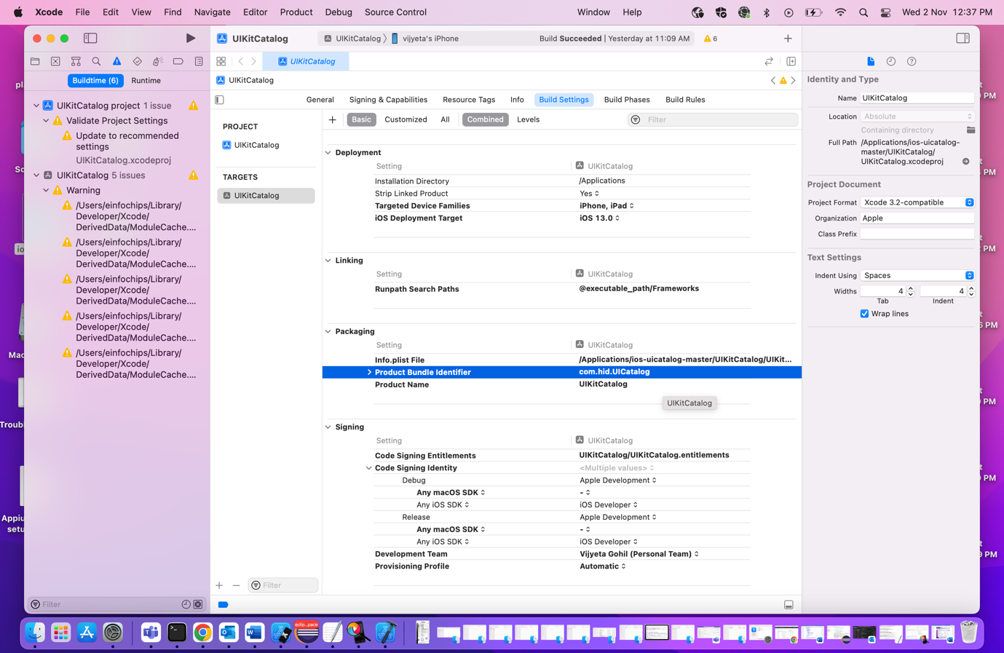

**Step 17: Check to inspect elements for the real devices, Give below capabilities and start the session**

